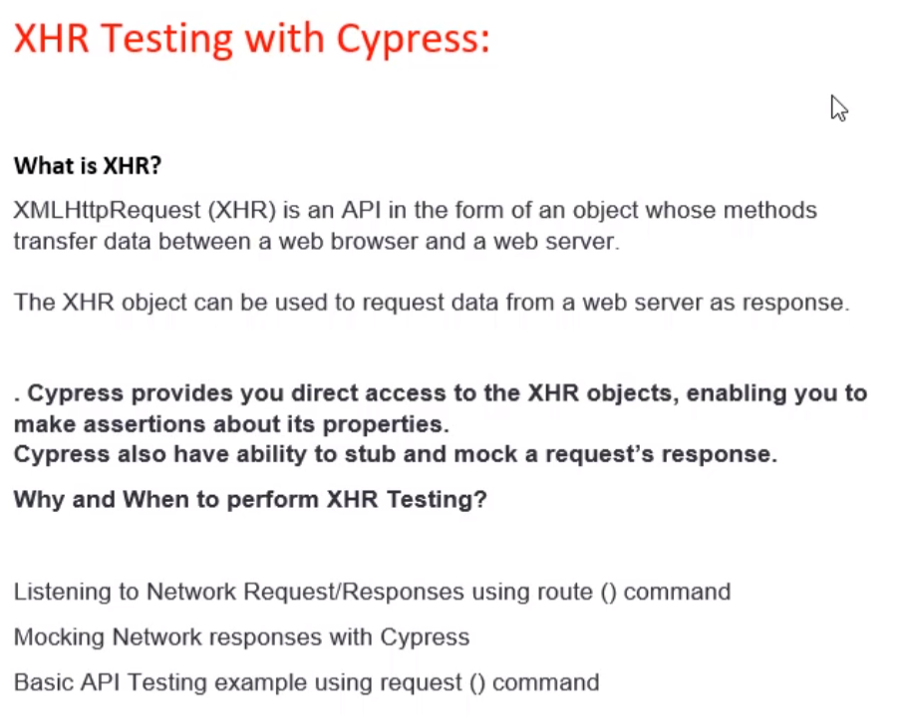 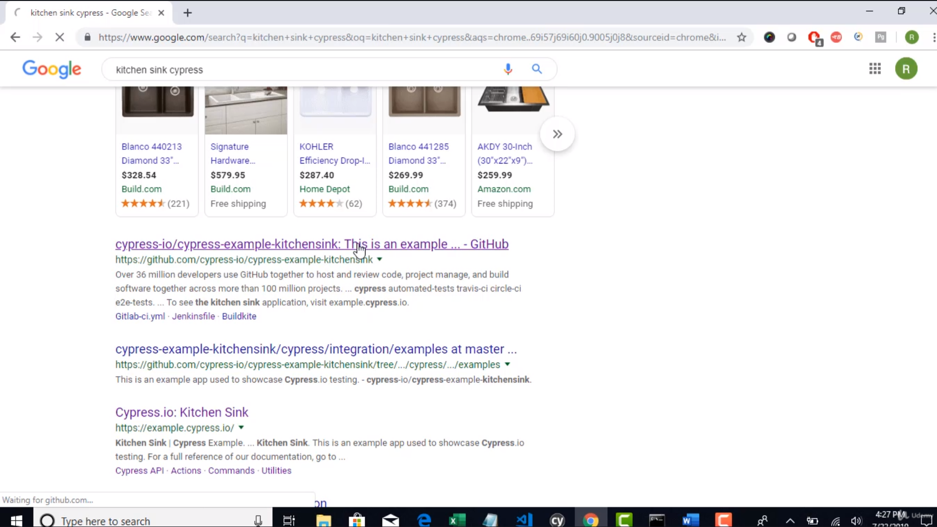 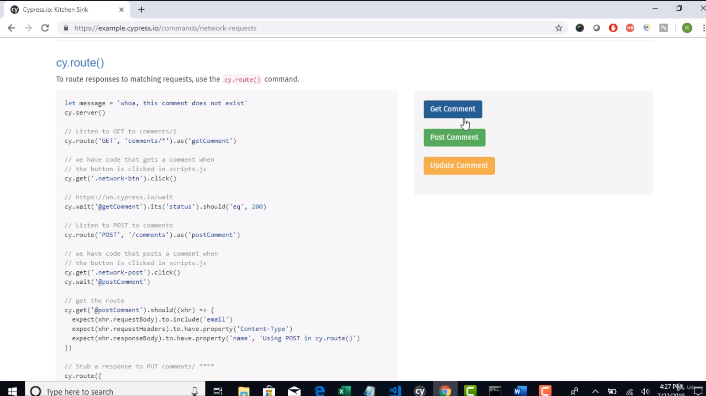

**API – Working:**

We send all our inputs to the backend server >>

backend server responds back to the browser >>

browser responds and renders the content of the app on the browser

Example:

Above lets try to click Get Comment - Lets see what happens

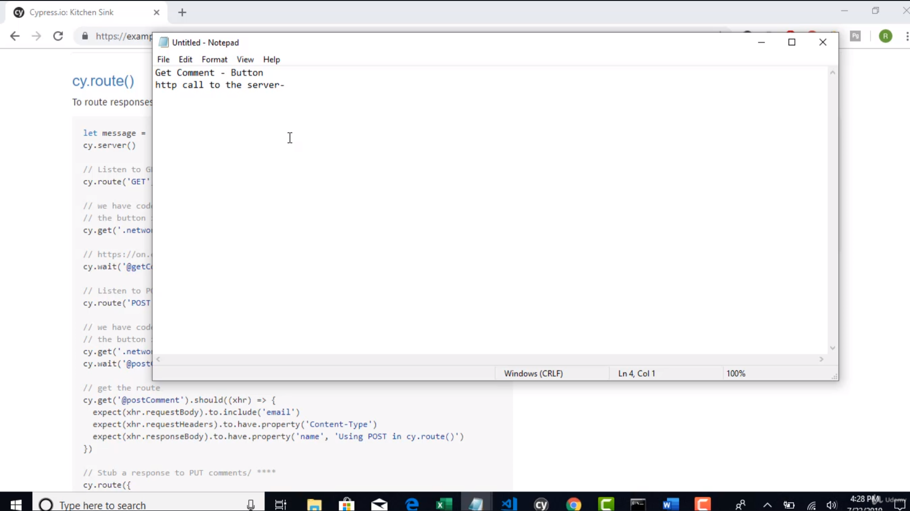 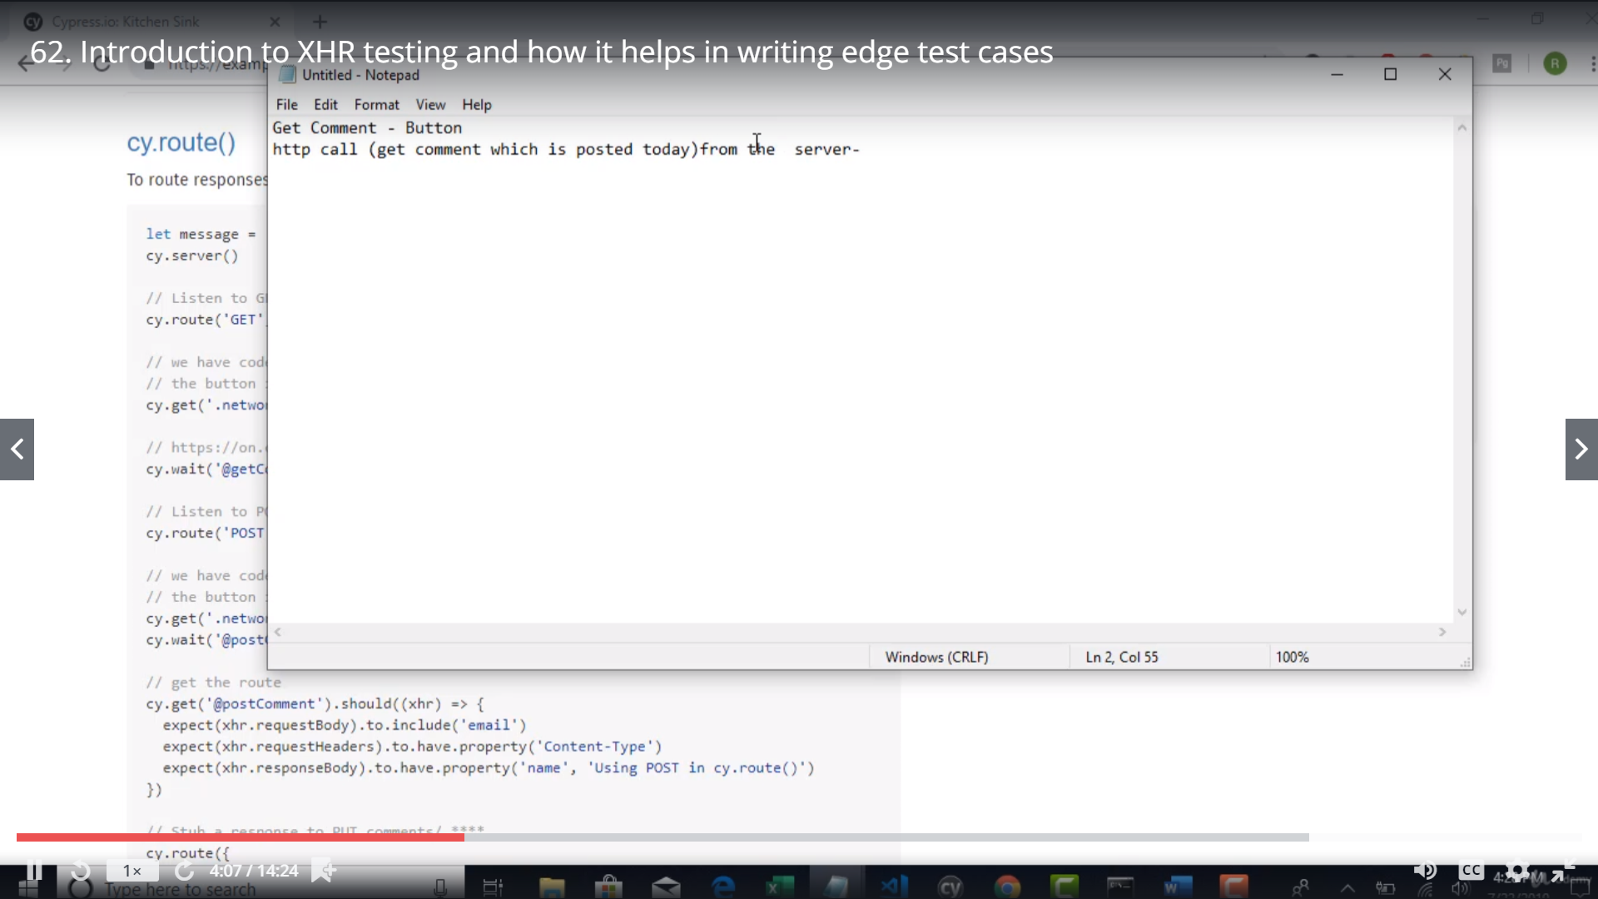 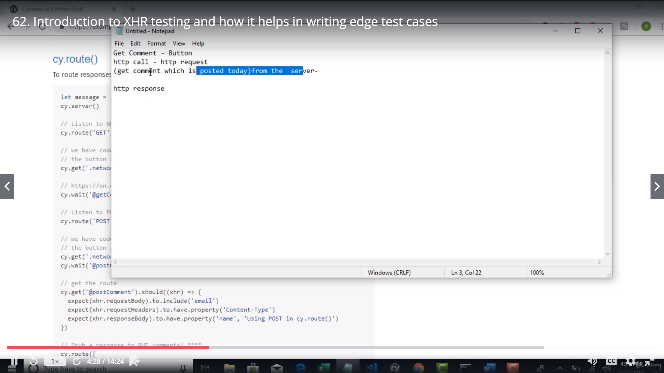 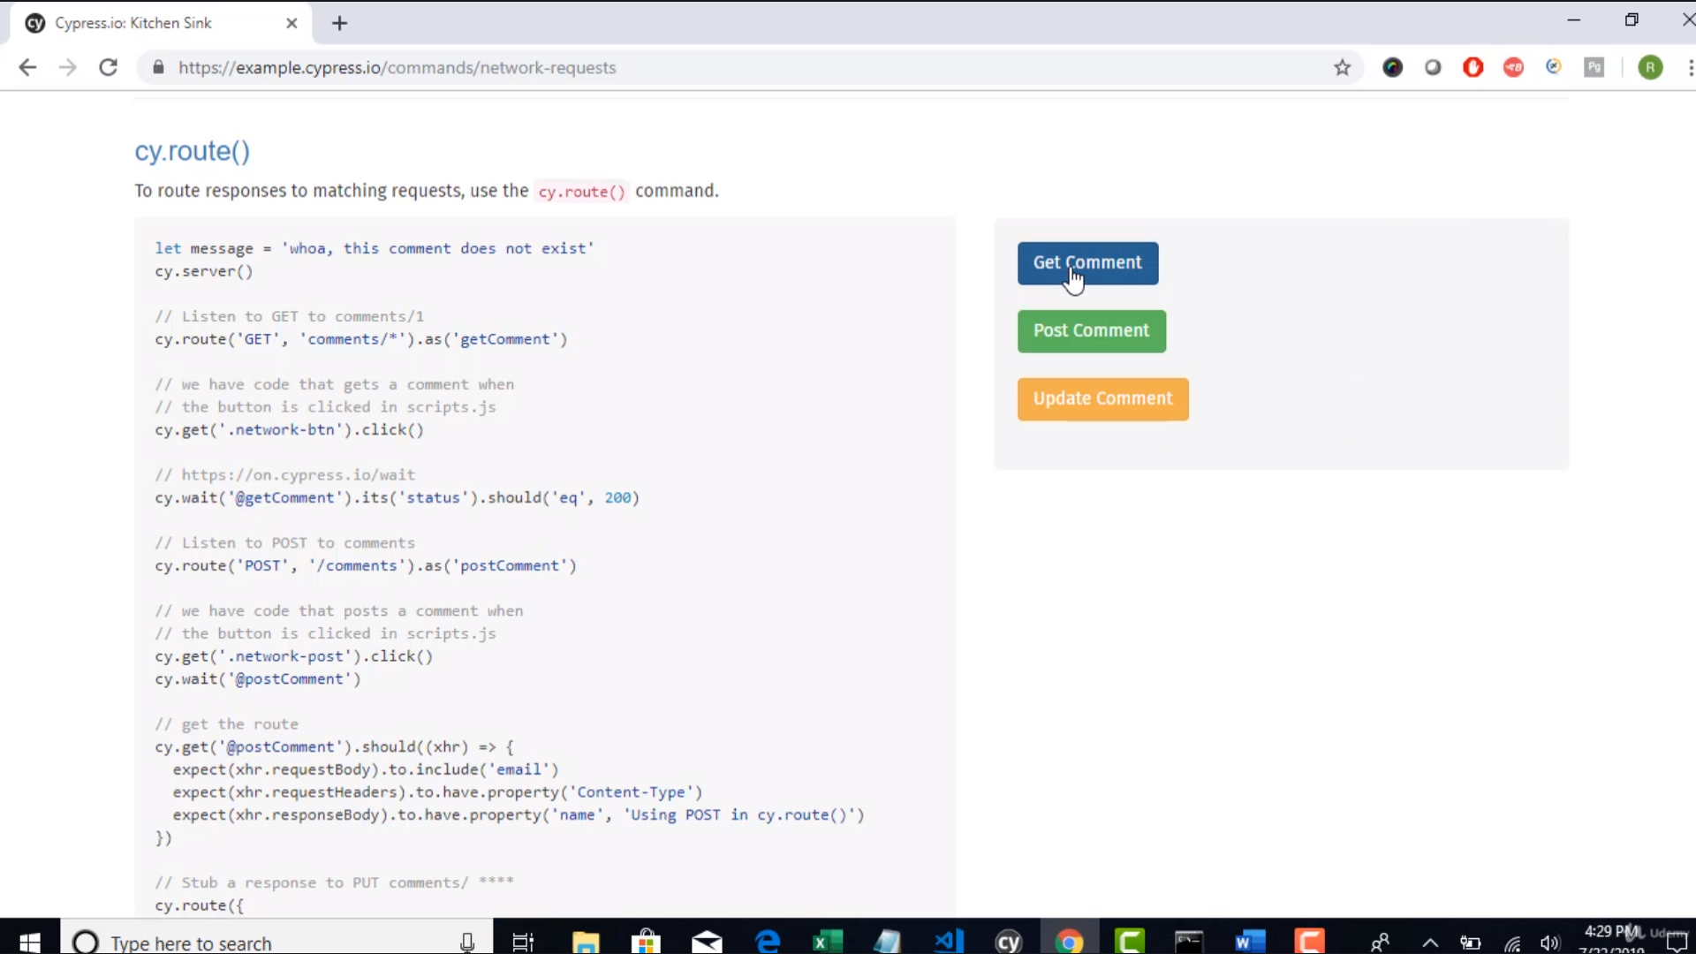 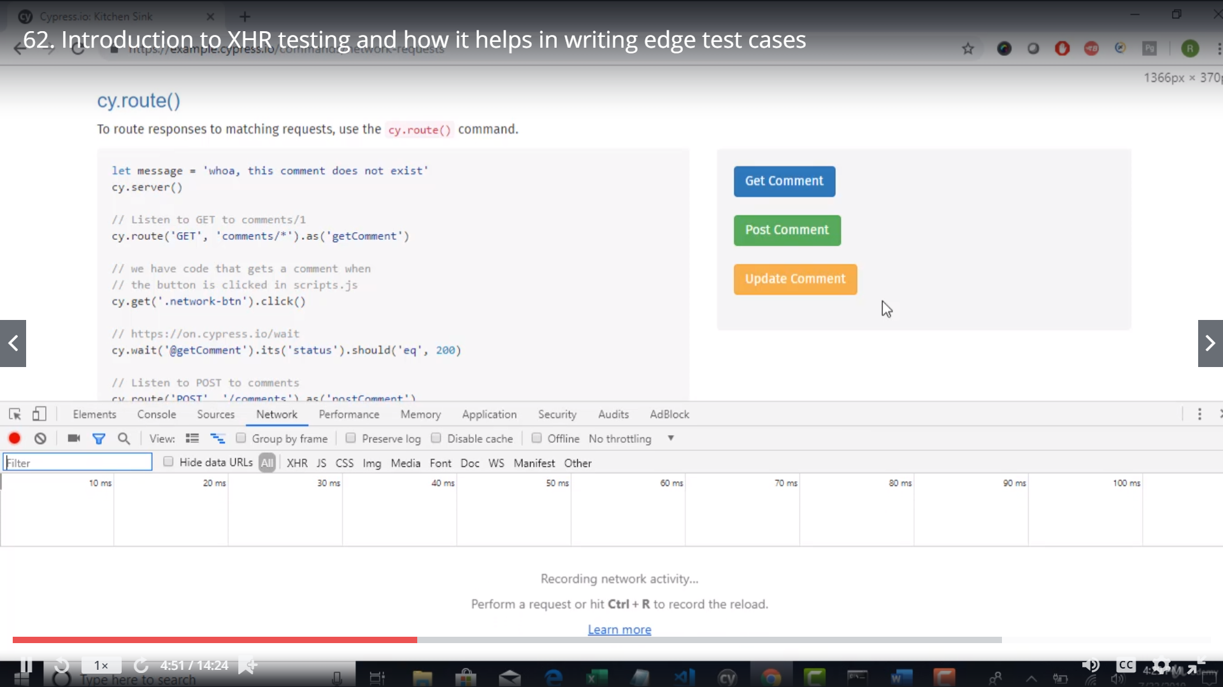 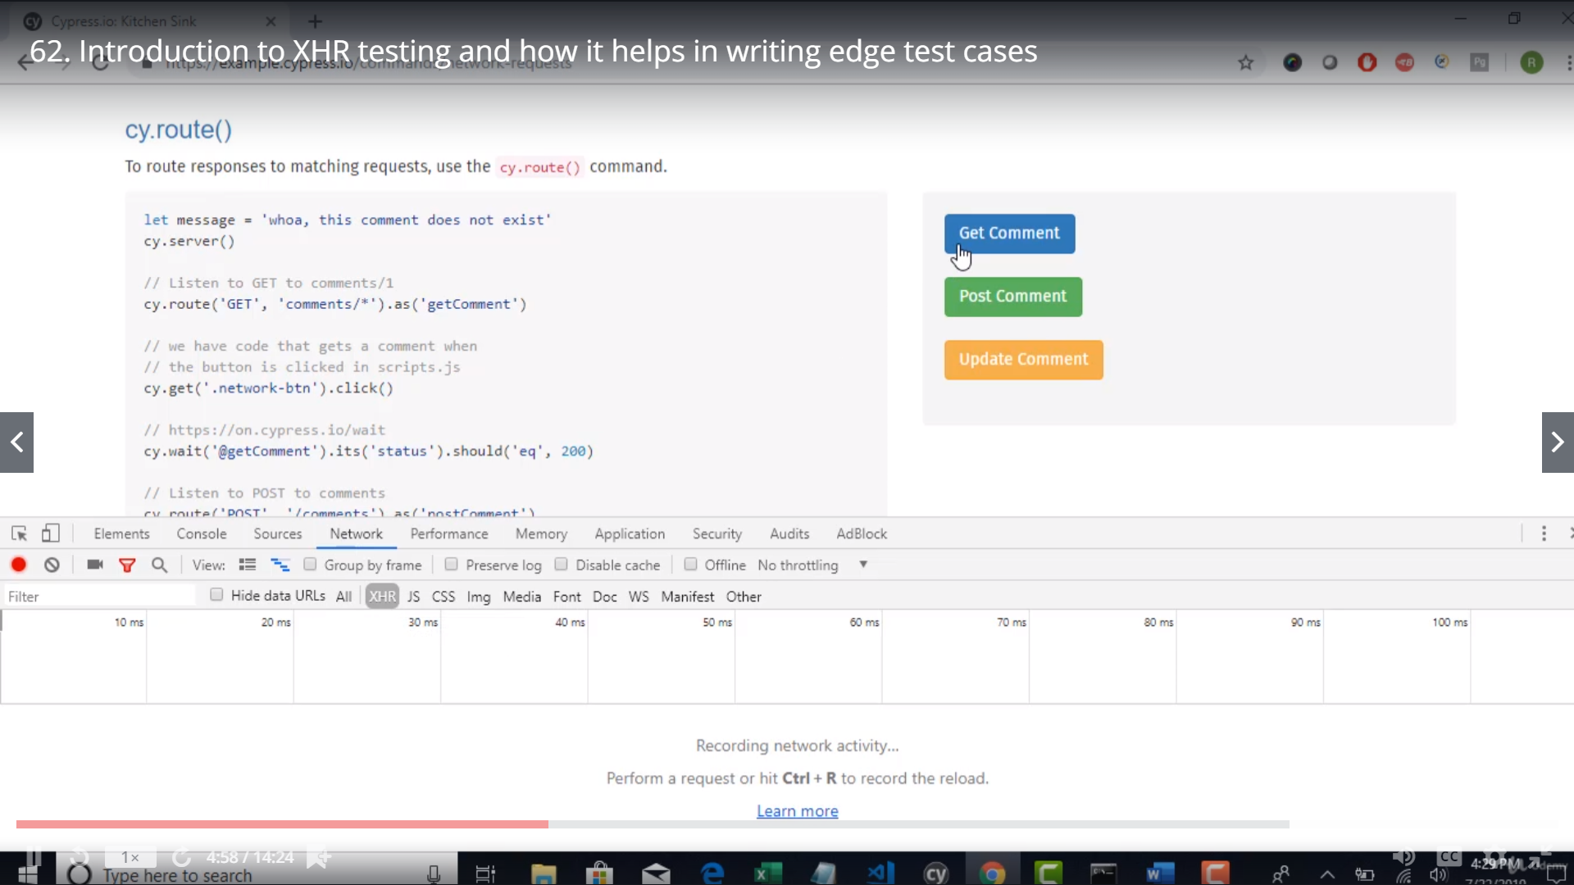 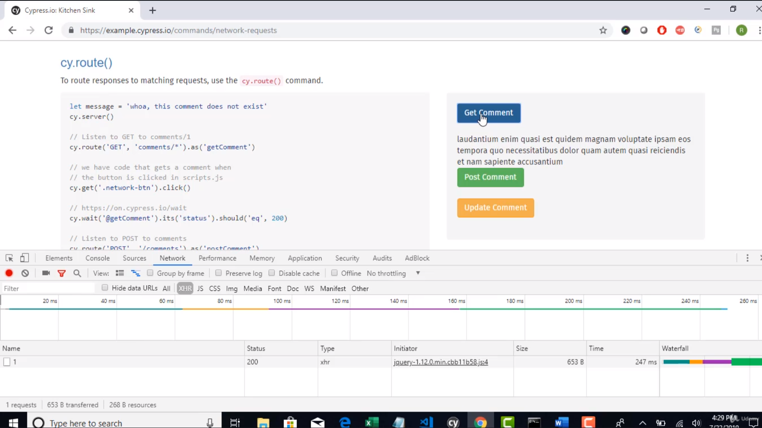

If u seee the n/w response

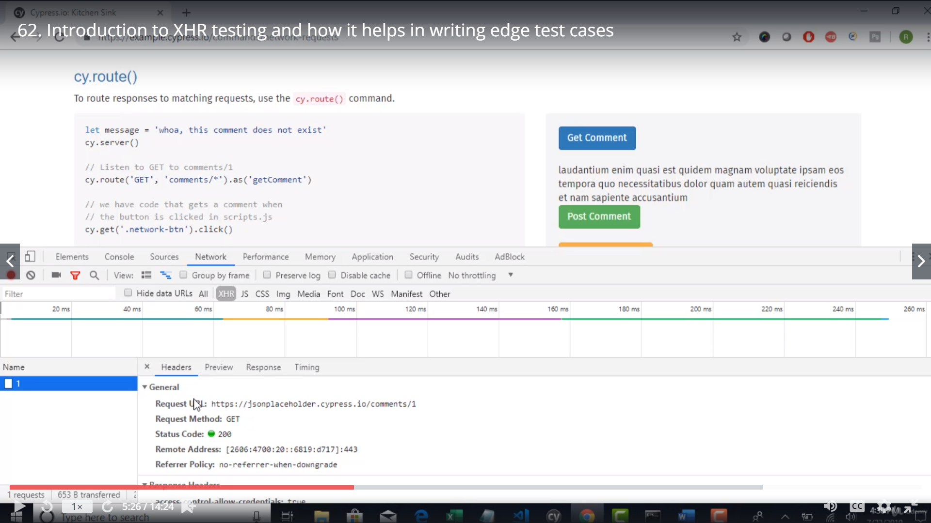

On clicking the ‘Get Cooment button’ the developers have made sure it hots the above url and gives the response.

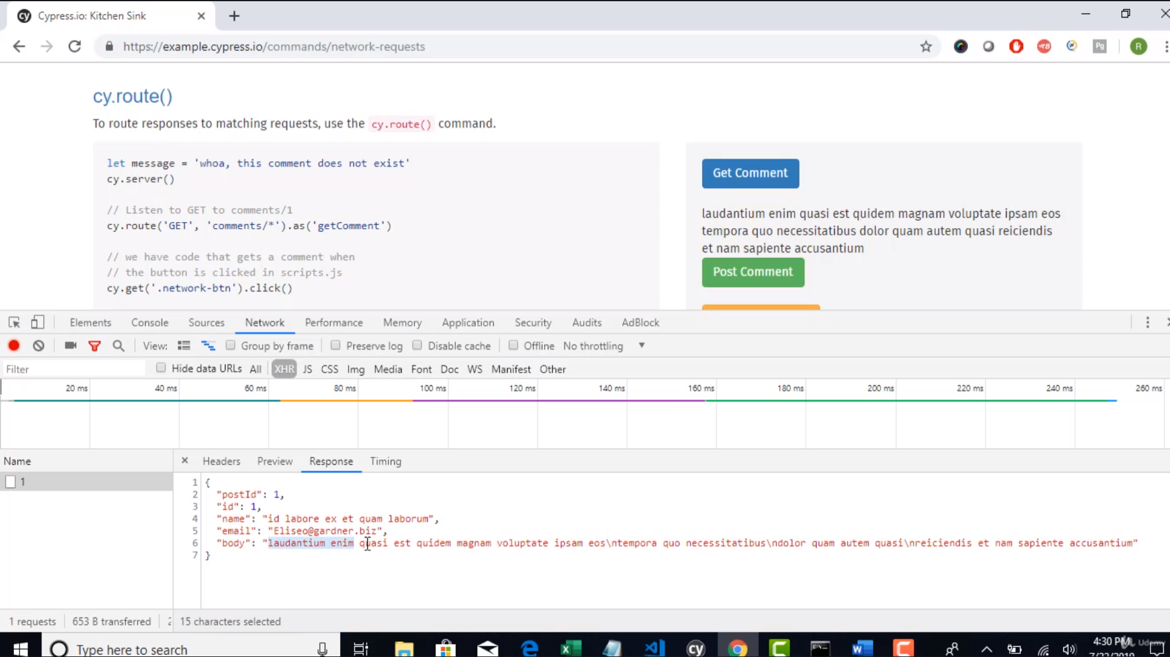 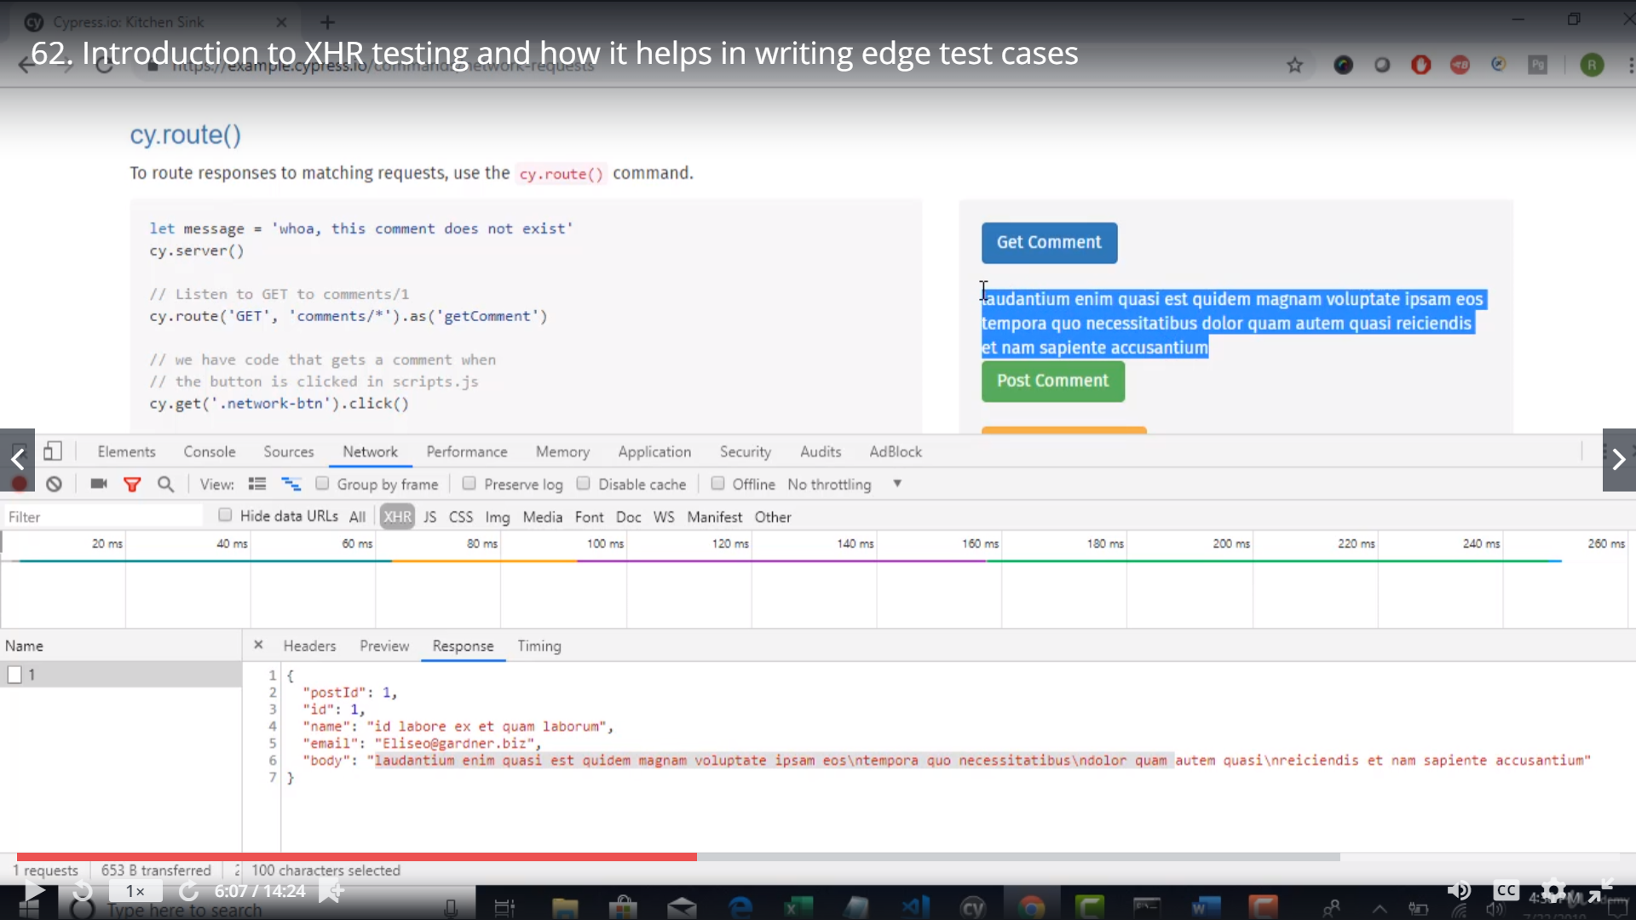

Whatever u r seeing here is visible here under the get comment – button

Basically the devloper has written code to copy the body of the response and print it on the browser

Cypress enables to access all the required data as the bosy etc…

Note: Cypress is the only tool in the market which can track ur request and responses

Cypress lisens to all the calls(request and responses

) it has made..

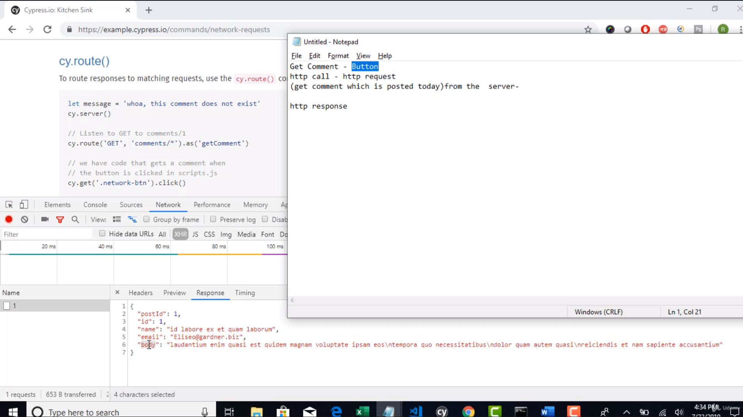

Day 1 – Hit ‘Get comment’ >> response form server read by client and stored in String and displayed on UI

Day 1 – Hit ‘Get comment’ >> response is 404 form server so not read by client,,, but string has yesterdays value and displayed yesterdays data on UI

Question : How o ensure the right comment is displayed on the UI?

You can tell only when the http call was a success

Normally – ppl would say this is not a candidate for automation.. But with cypress .. Yes

So with the help of XHR we can validate … the responses of the api

This can be achieved by integrating Selenum+restassured

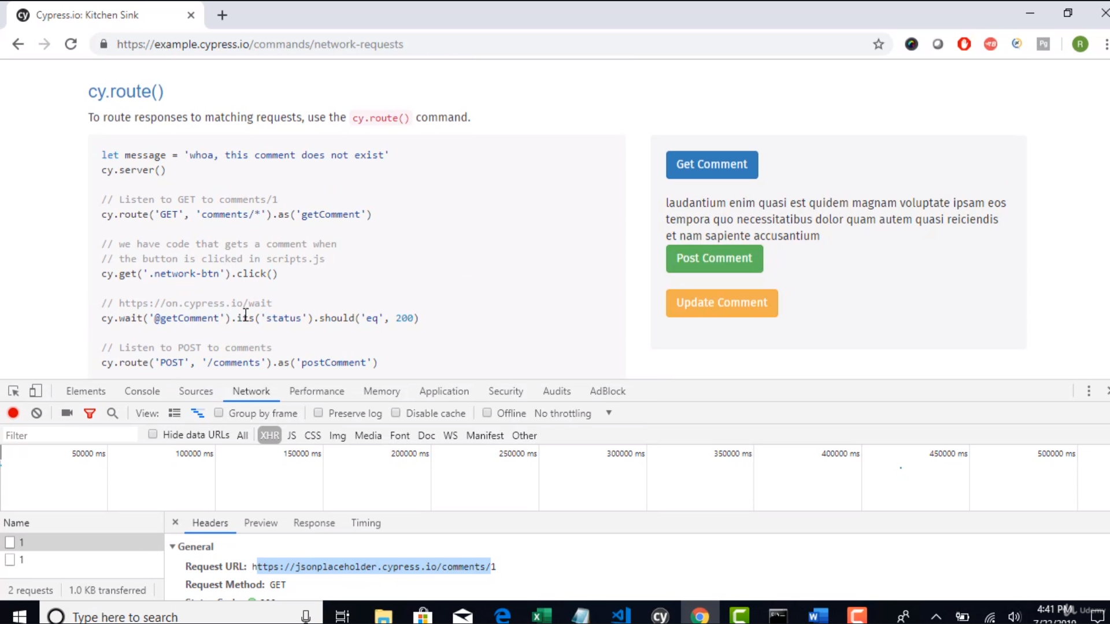

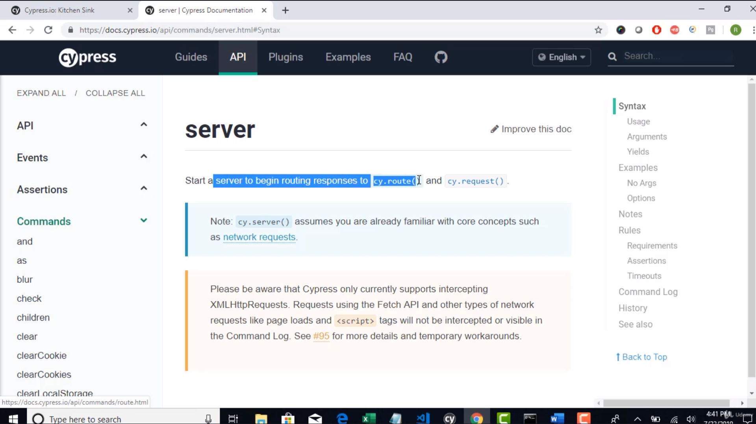

Cy.route - takes different argument

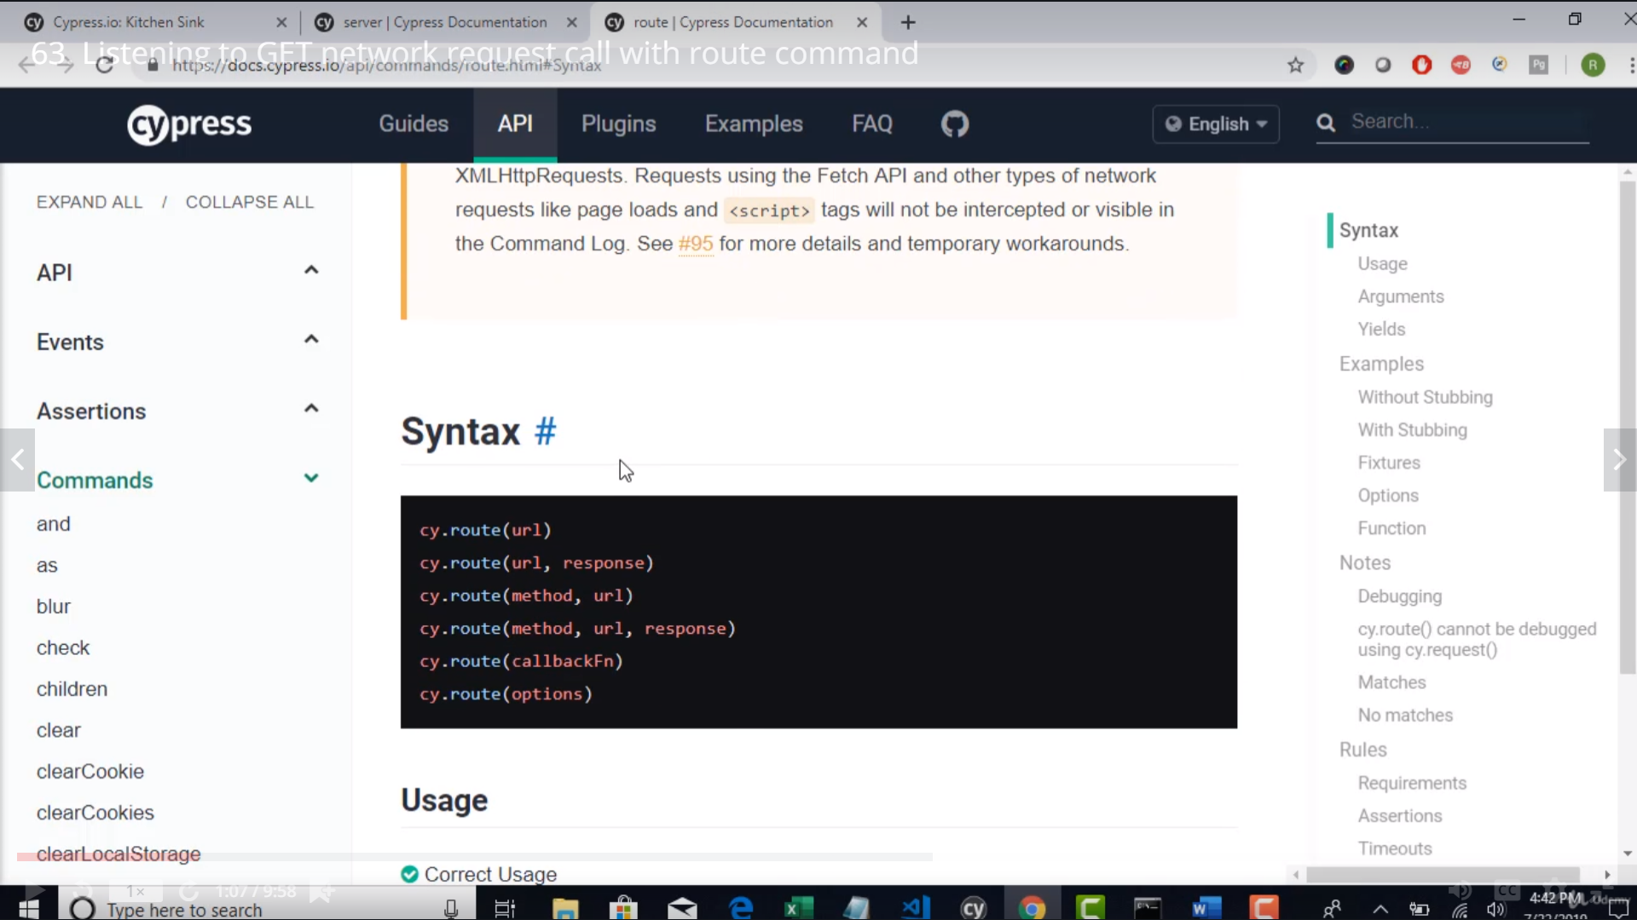

Method – Http methods get ,post etc

url – endpoint

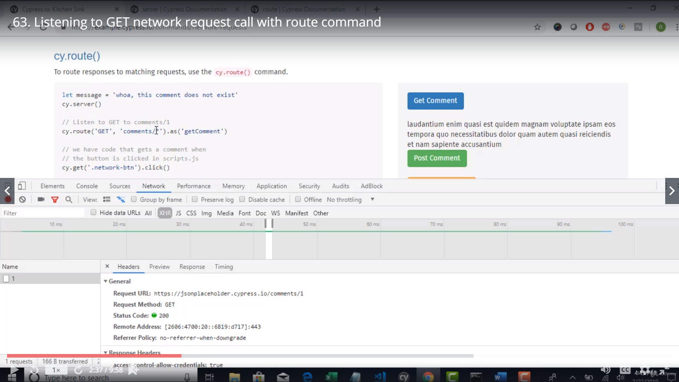

Cy.route(‘GET’,’comments/*).as(‘getComment’)

/* - is uses since to use regular expressions

Cy.route – will help cypress to scan all ur incomeing requests on ur browser

And if it comes across the above endpoint >> and assign/alias that service call to ‘getComment’

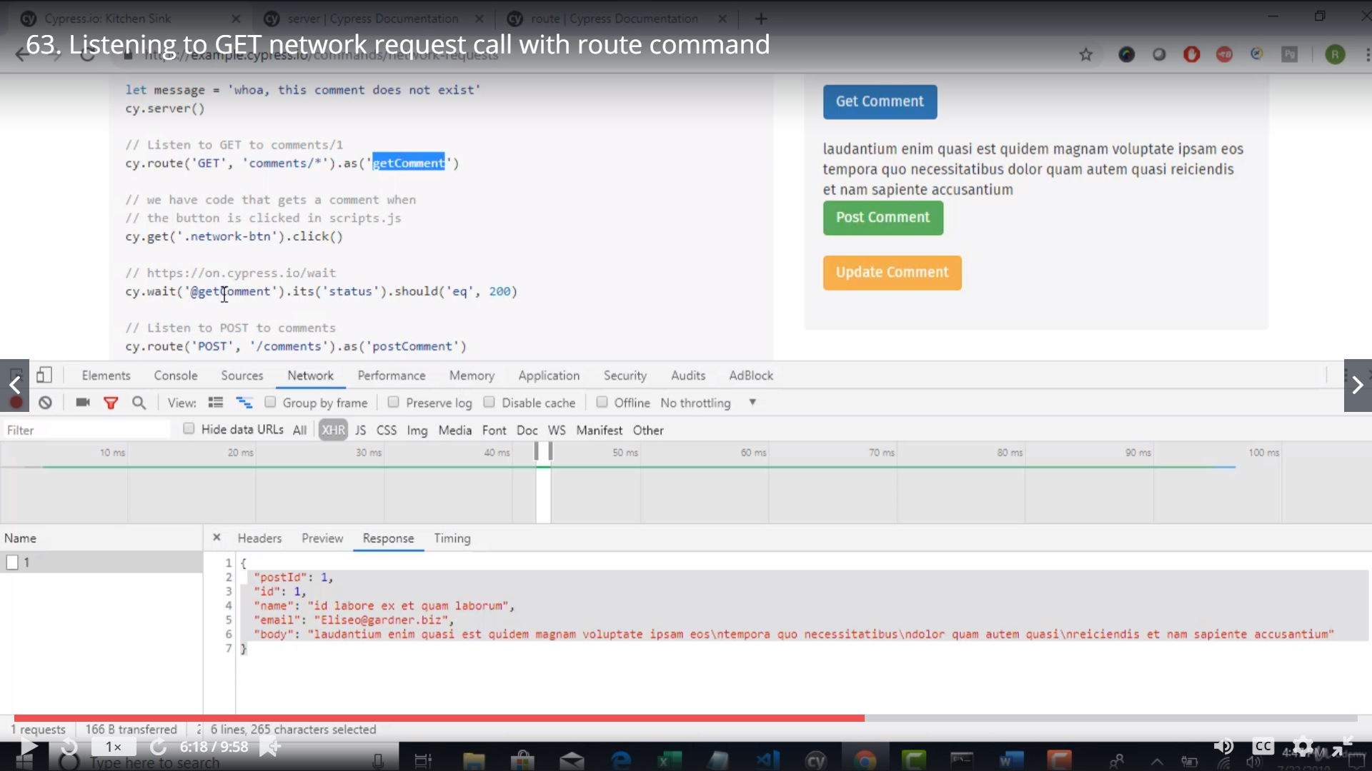

Cy.wait(‘@getComment’) - its using the alias ‘getComment’ to make sure it waits until the response is received..

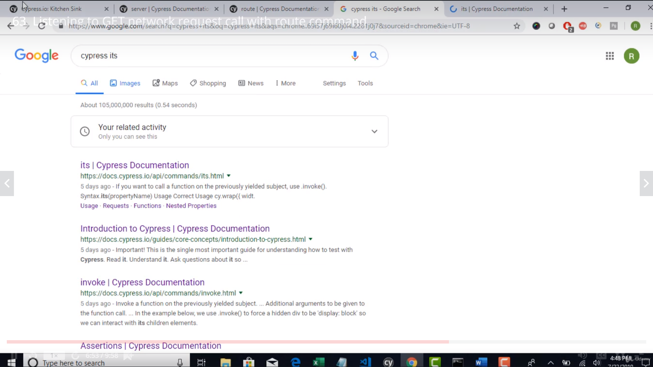

What is its

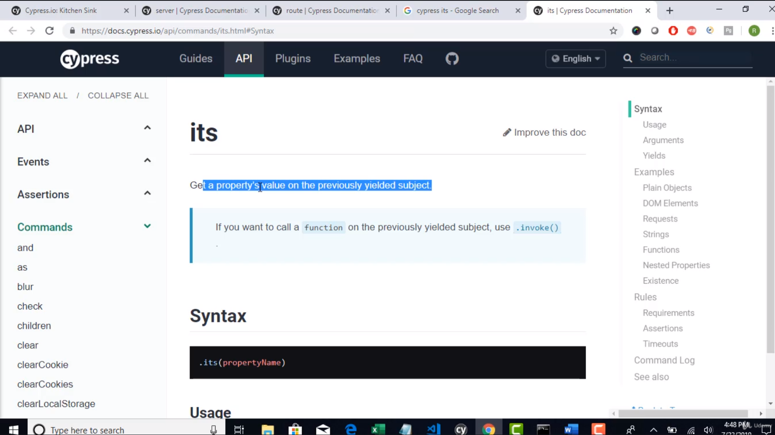

POST

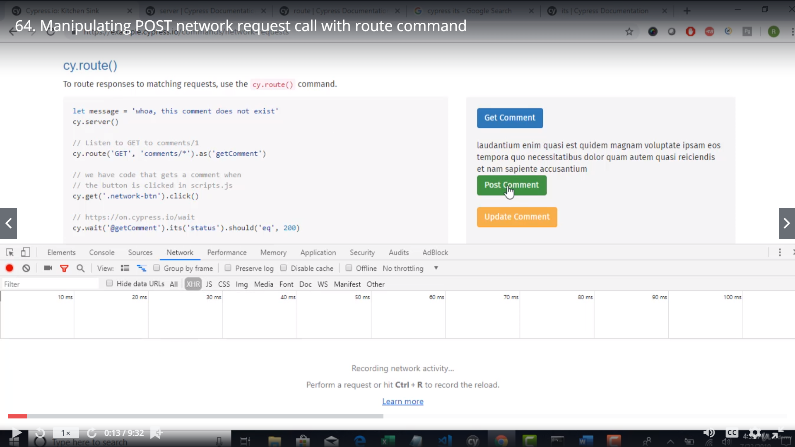

Click on ‘Post Comment’ – Button

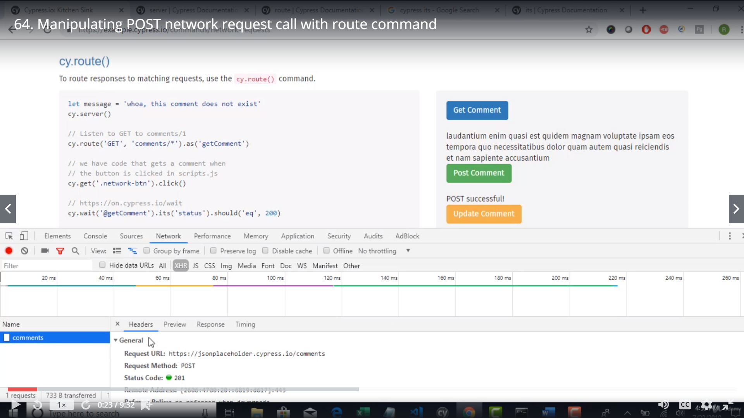

Http post call was made with response 201

Post will update the comment in the DB..

But we need not go the DB and verify it..

We can simply check the api being triggered when we clisk the button..

Then verify if the request and response of the api were successful when the button was clicked.

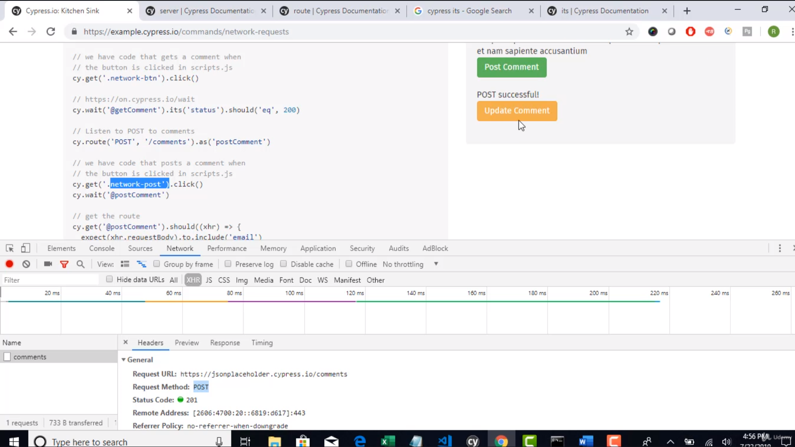 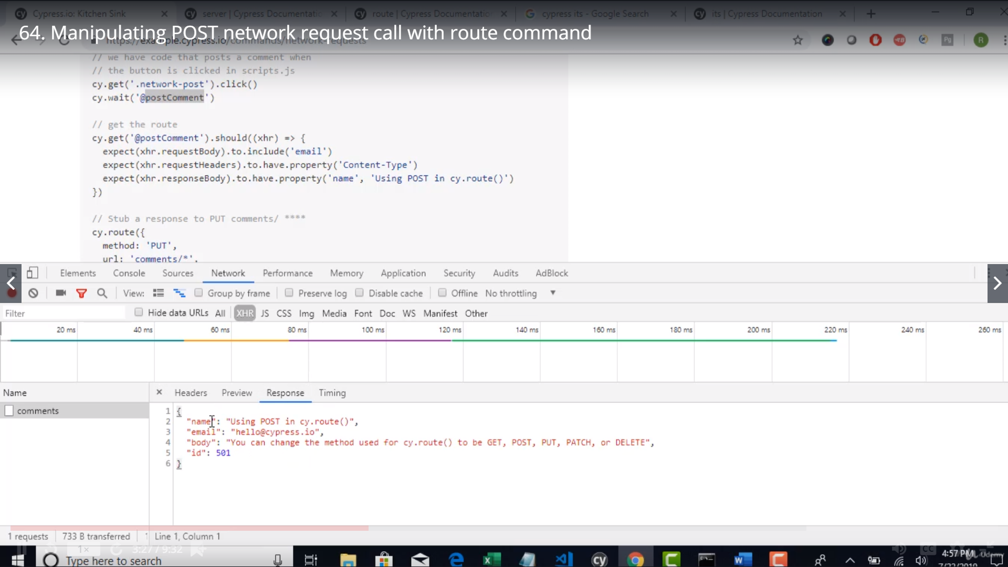

Cy.get .. gets all the ouput

And then u resolving as a promise using should

Assertion on XHR object

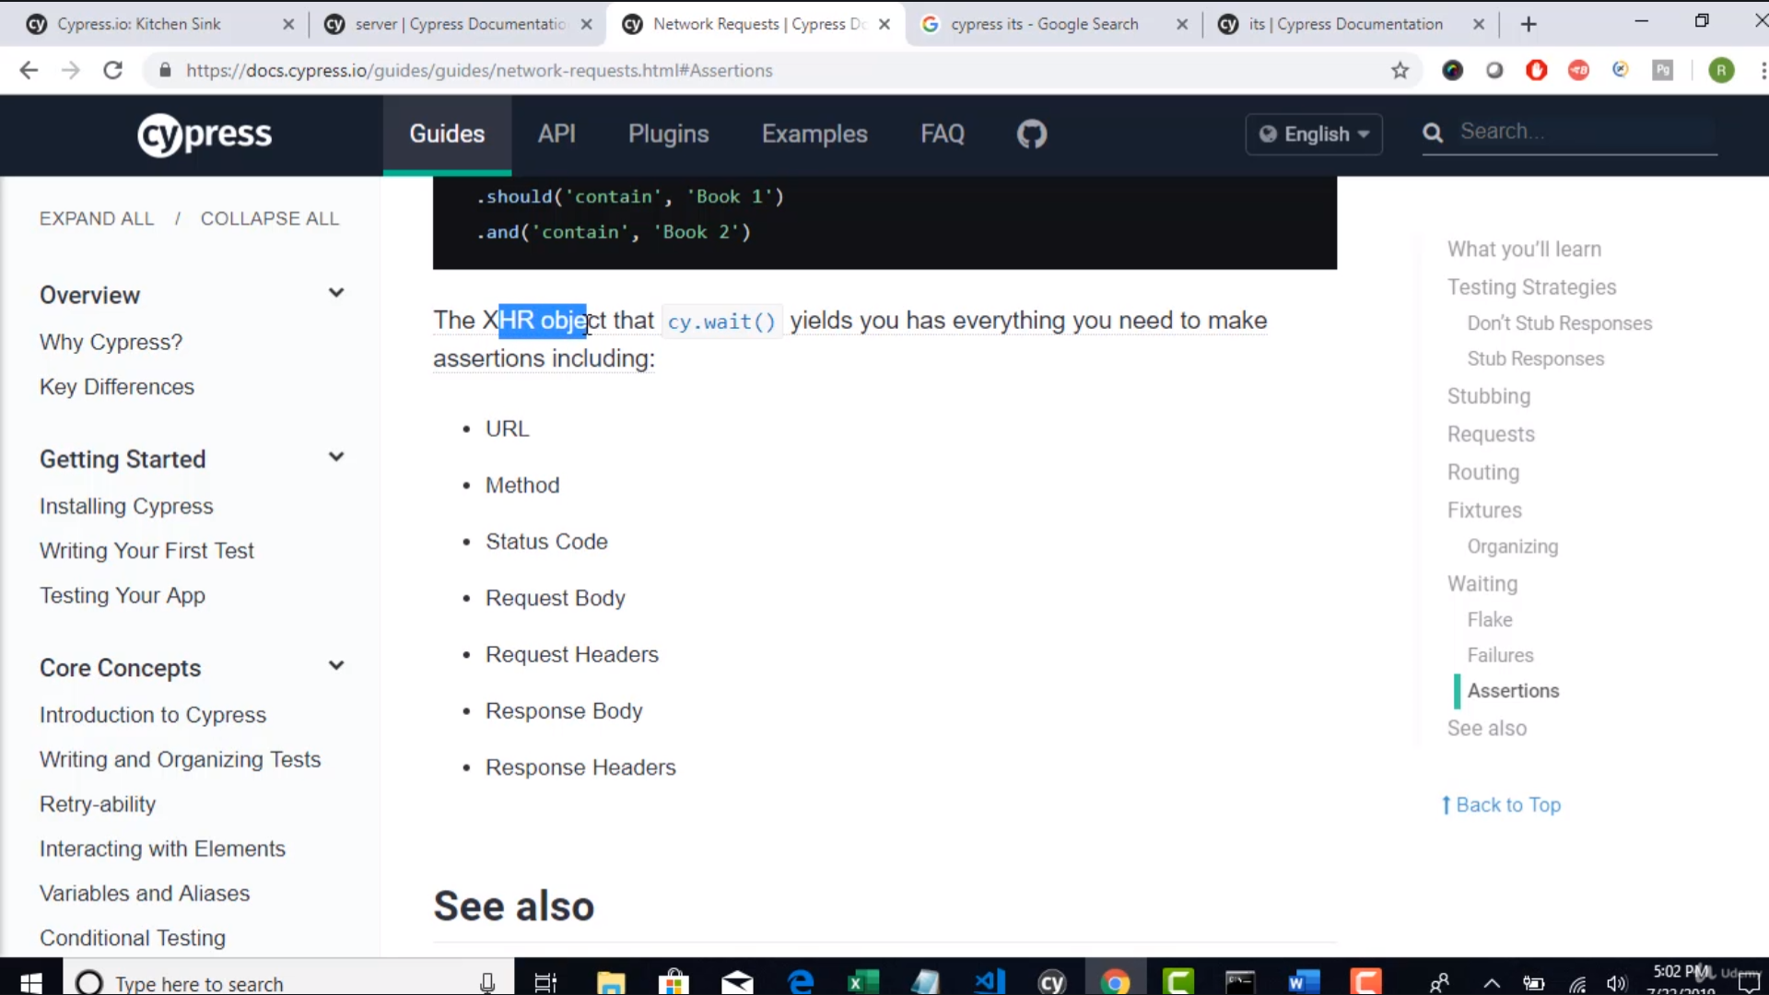

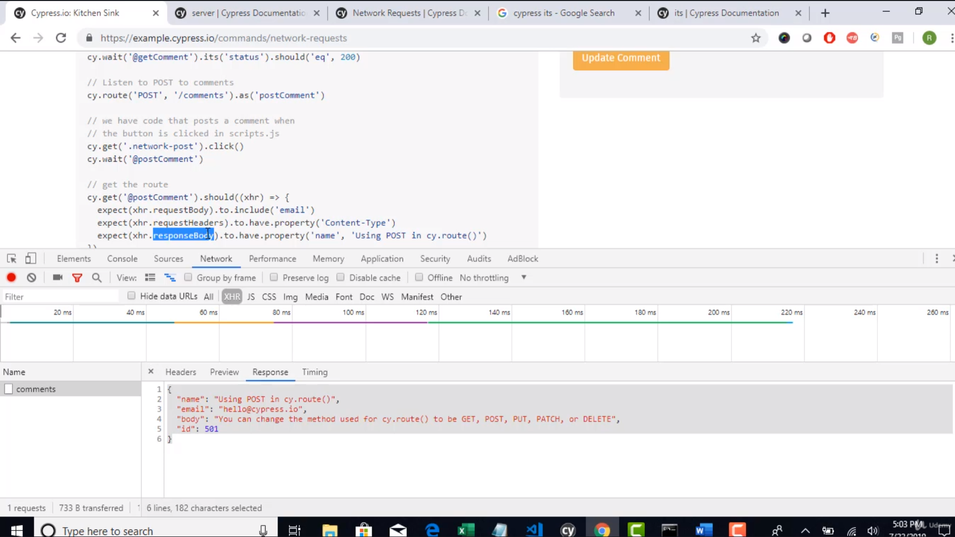

Now we will understand how to mock ur api calls using cypress

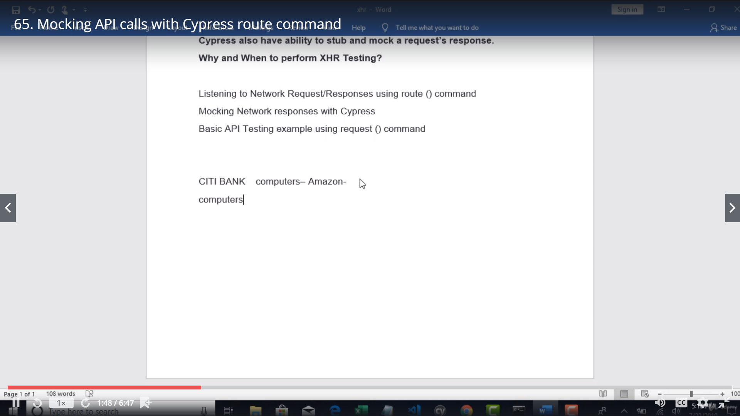

Say u have an account with CITI – Bank and recently amazon has tied up with CITI and u can purchase amazon items via CITI…(not all items available on amazon woud be available …. But based on the MOM only selected items would be avilable)

So.. How will u test the below scenario:

Case 1> When the amazon service is down and user is trying to access

* User to get a message - Sorry we cant retrieve Amazon products

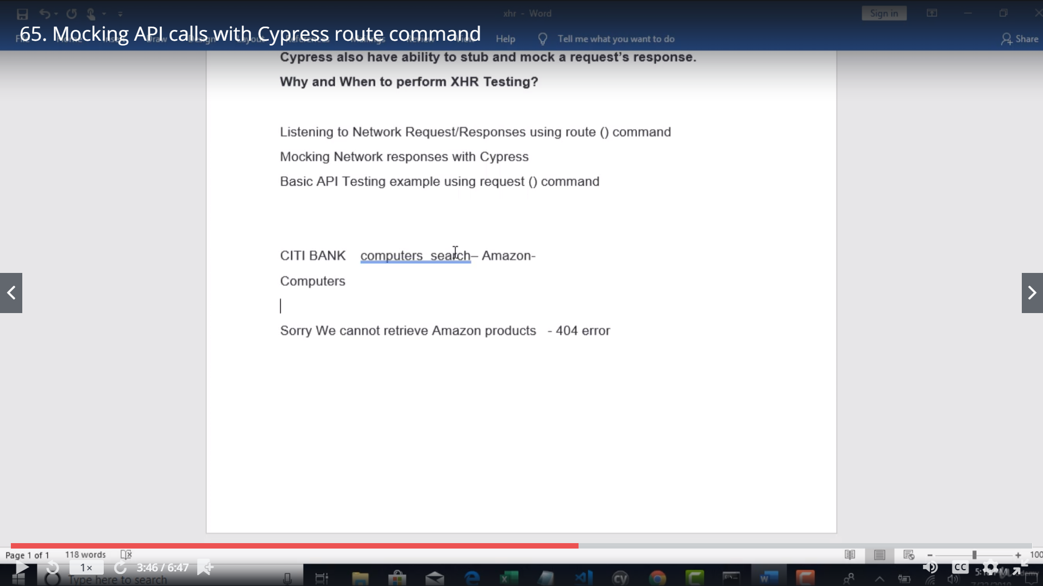

So basically when u r searching for “amazon” --- an api is connecting to amazon and searching

So in above case we need to make sure the api is responding with status 404

And then the front end logic reads the 404 and renders the error message ‘could not retrieve results”

Then u can test it

Using Cypress we can stop the original response and fake/mock the intended response to the browser

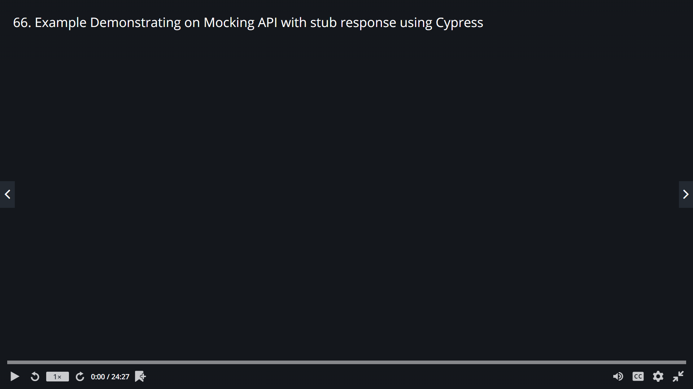

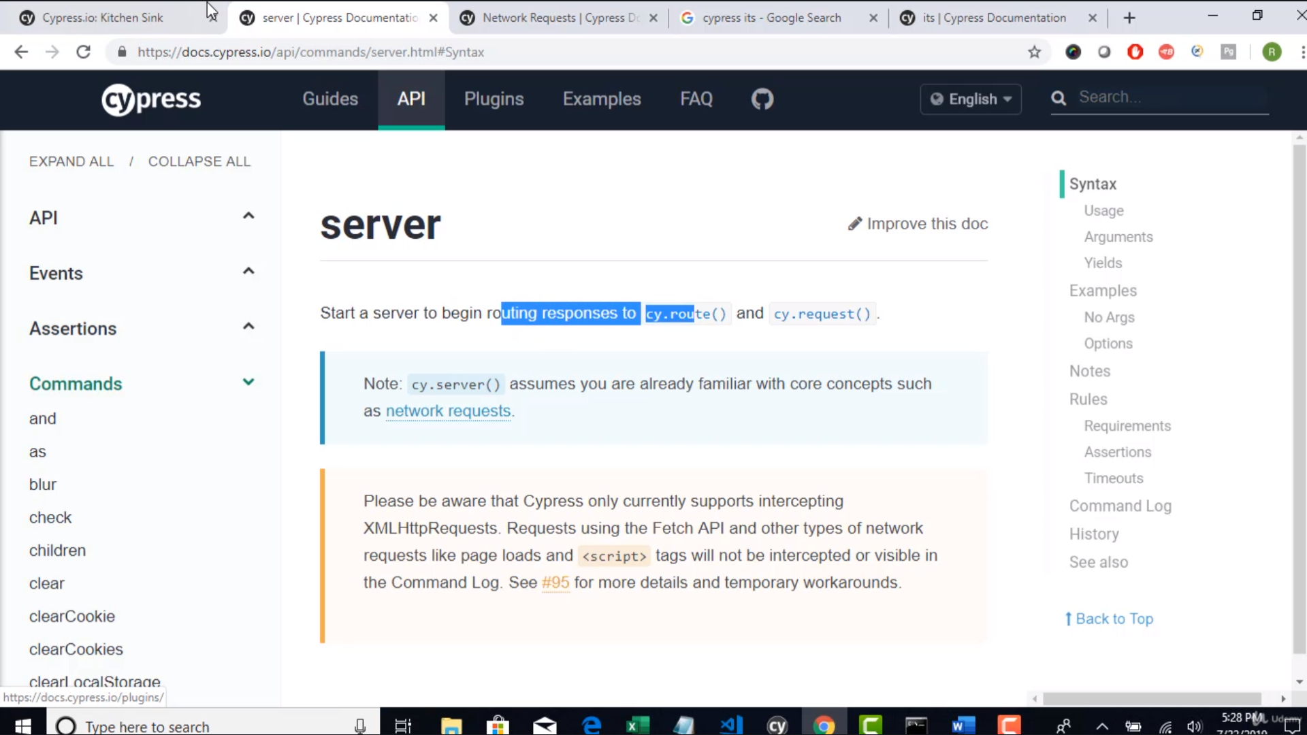

To initate listening to request/responses we have to start cy.server()

Then we have to listen and get the reponse and then change the repose to the fake response

Basically we need to completely stub the response

So we will use cy.route to listen

Route has capability to listen as well change the response

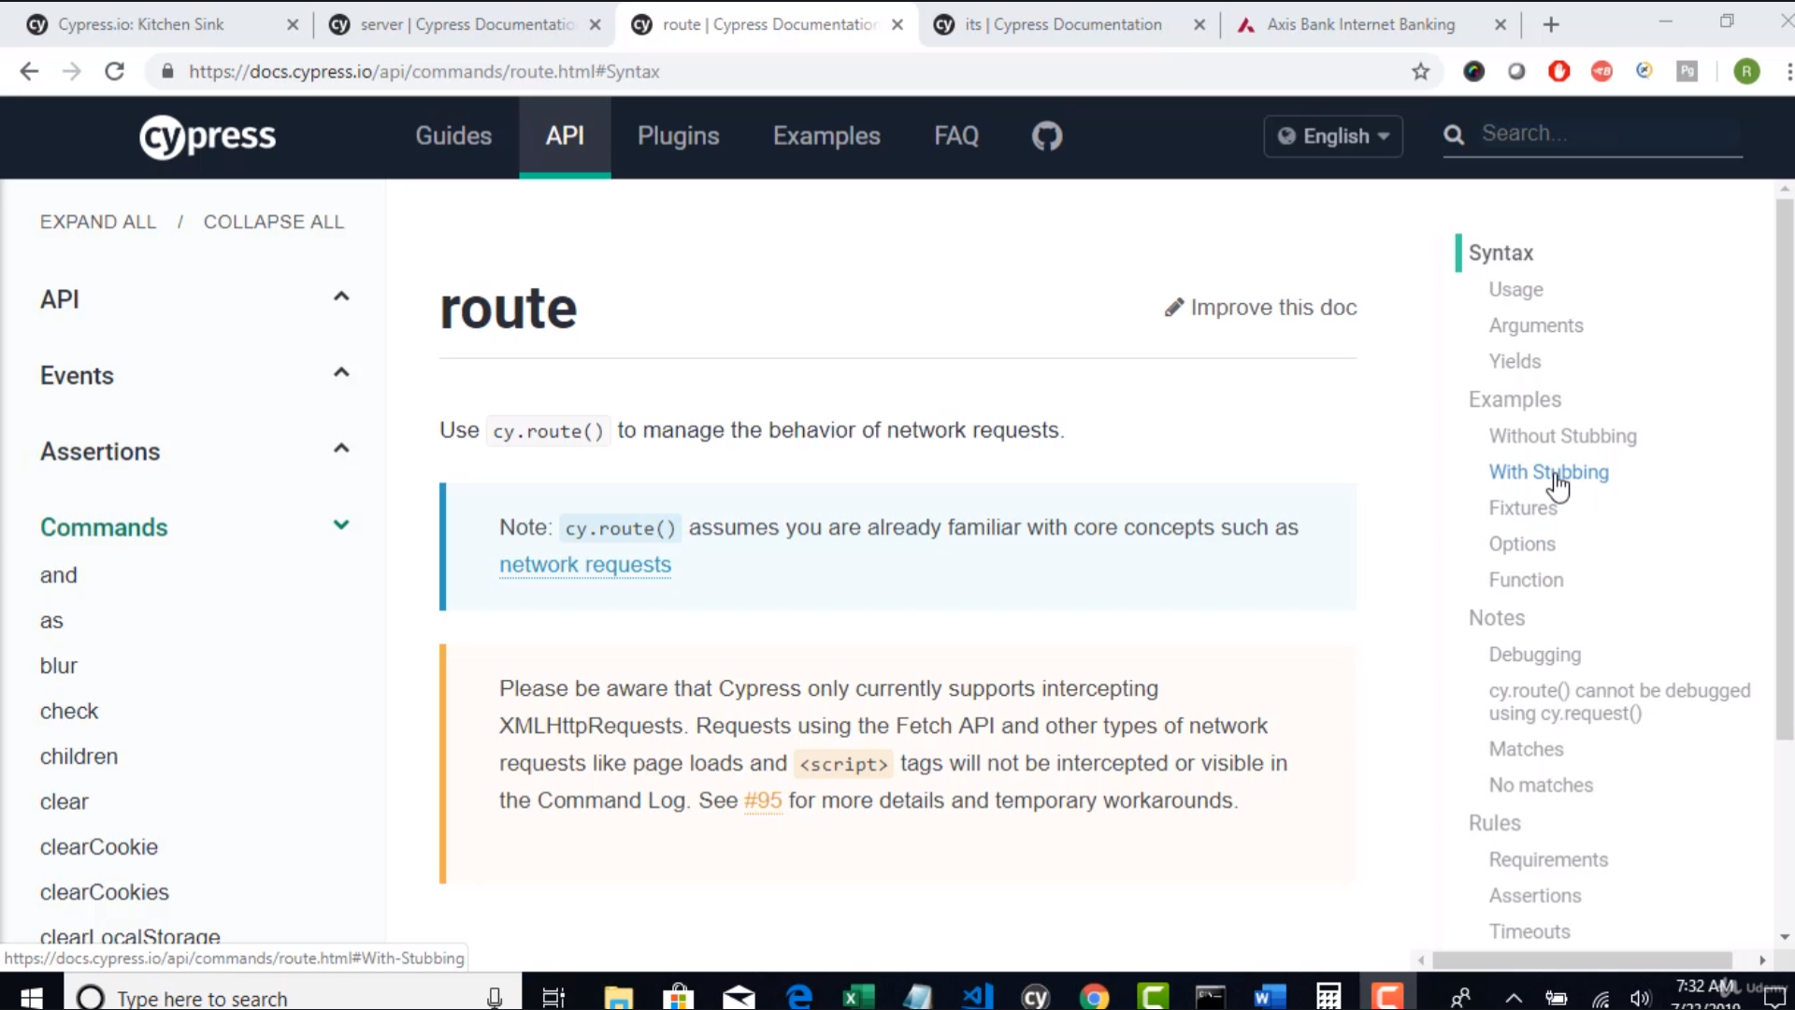

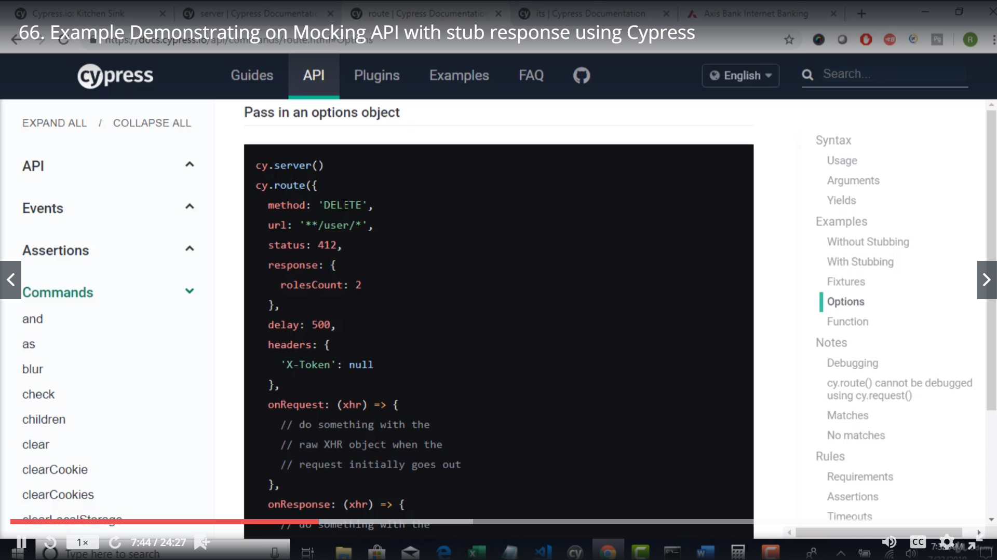

To stub u need to try in the above mentioned way

Method – intended request http Method get/post/etc

url – the intended end point

response – the intended response[U need to chk with developers the intended repose when the inrended status comes”

]

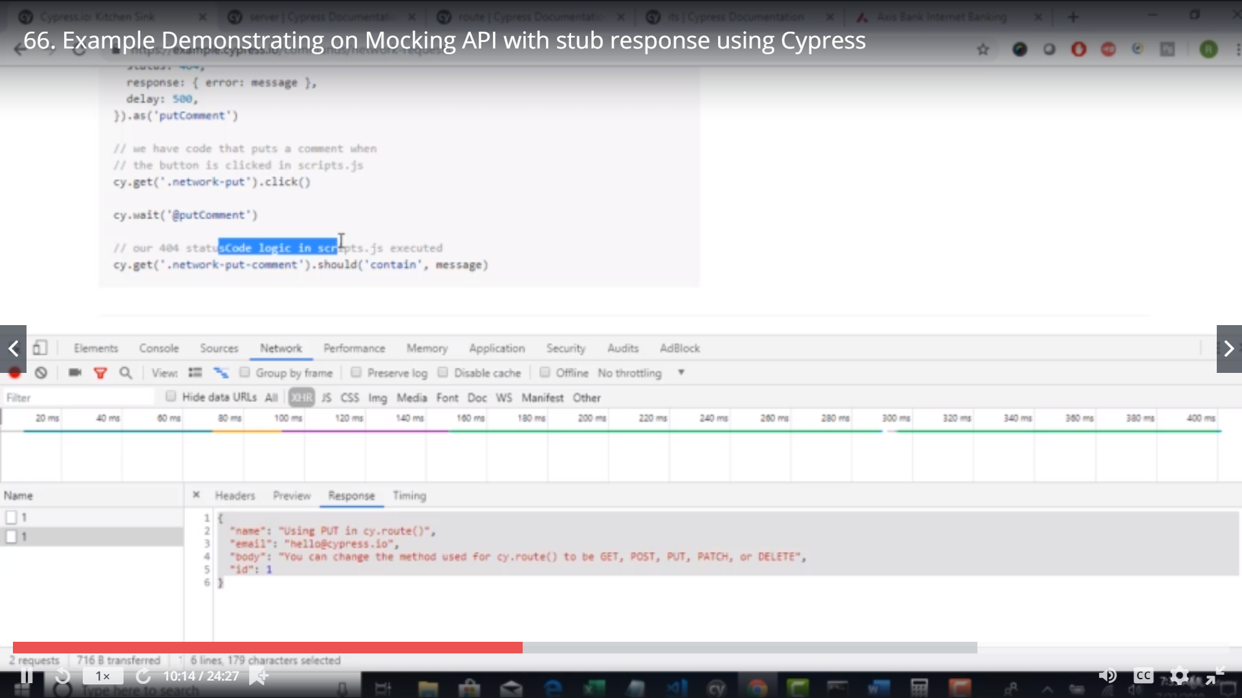 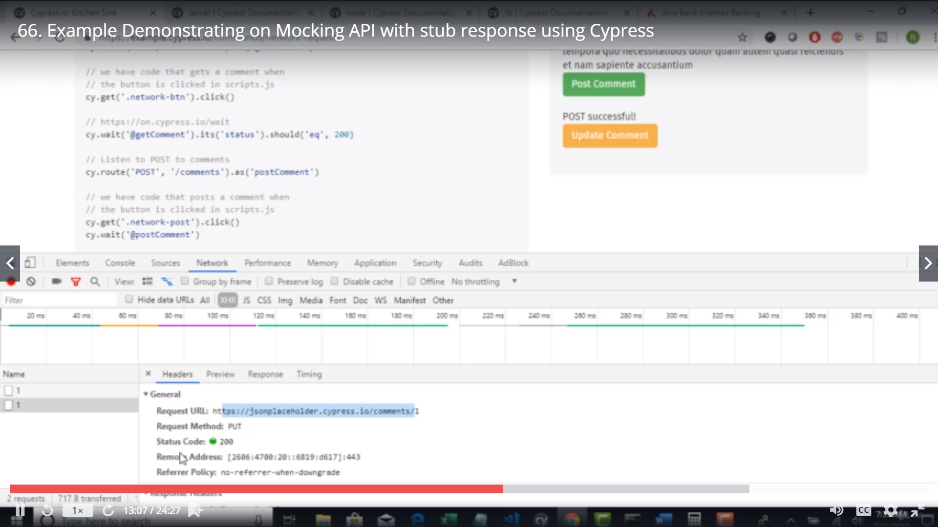

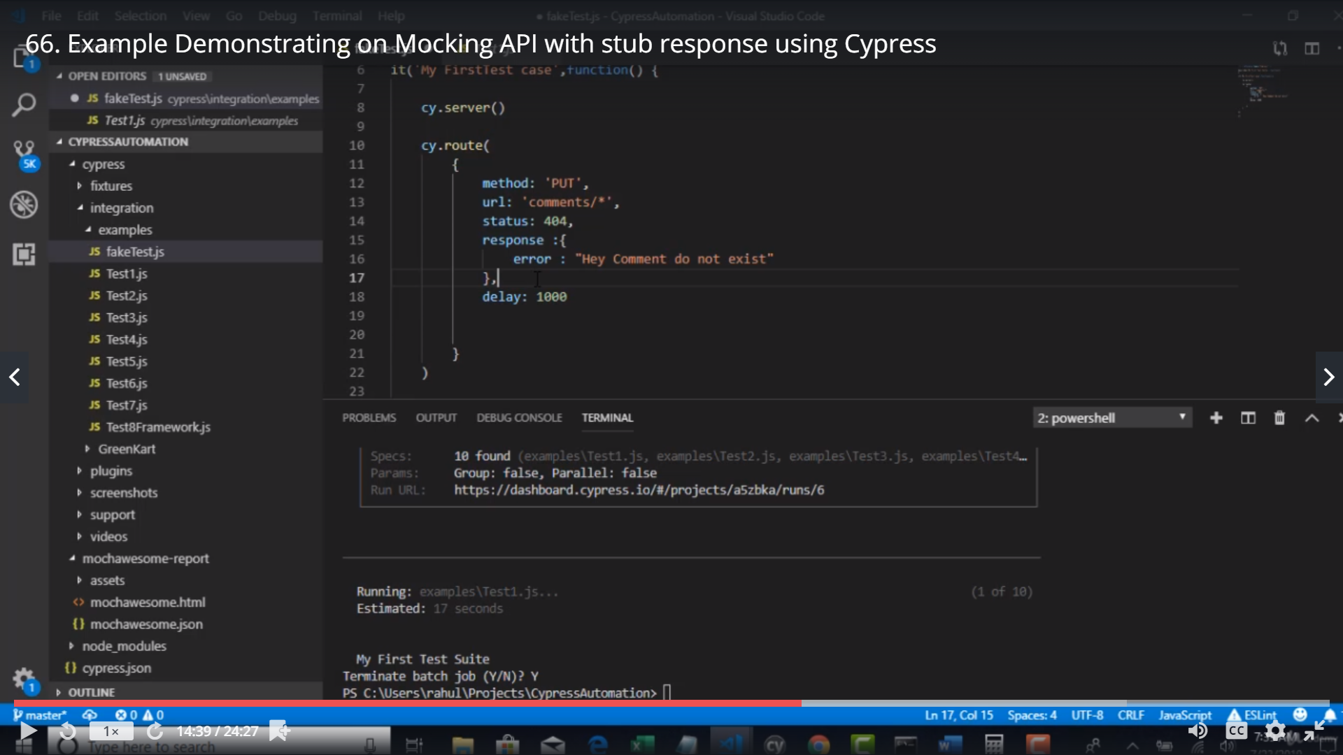

Delay is to delay the mock – 1000 is 1 milli sec[doesn’t matter much]

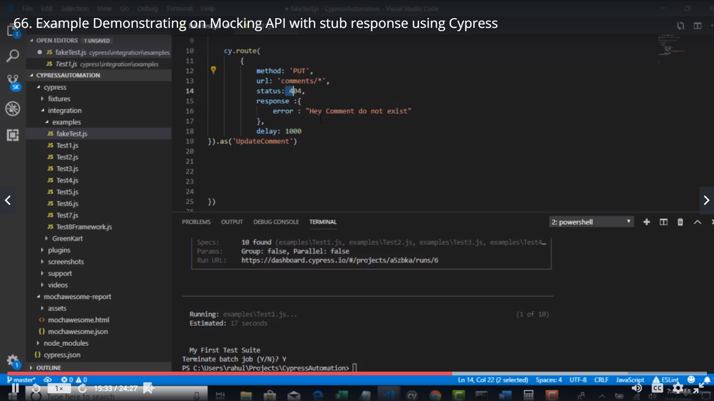 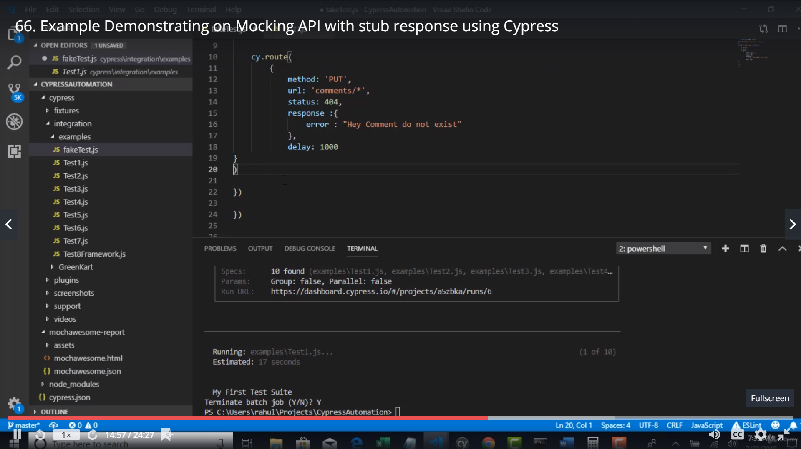 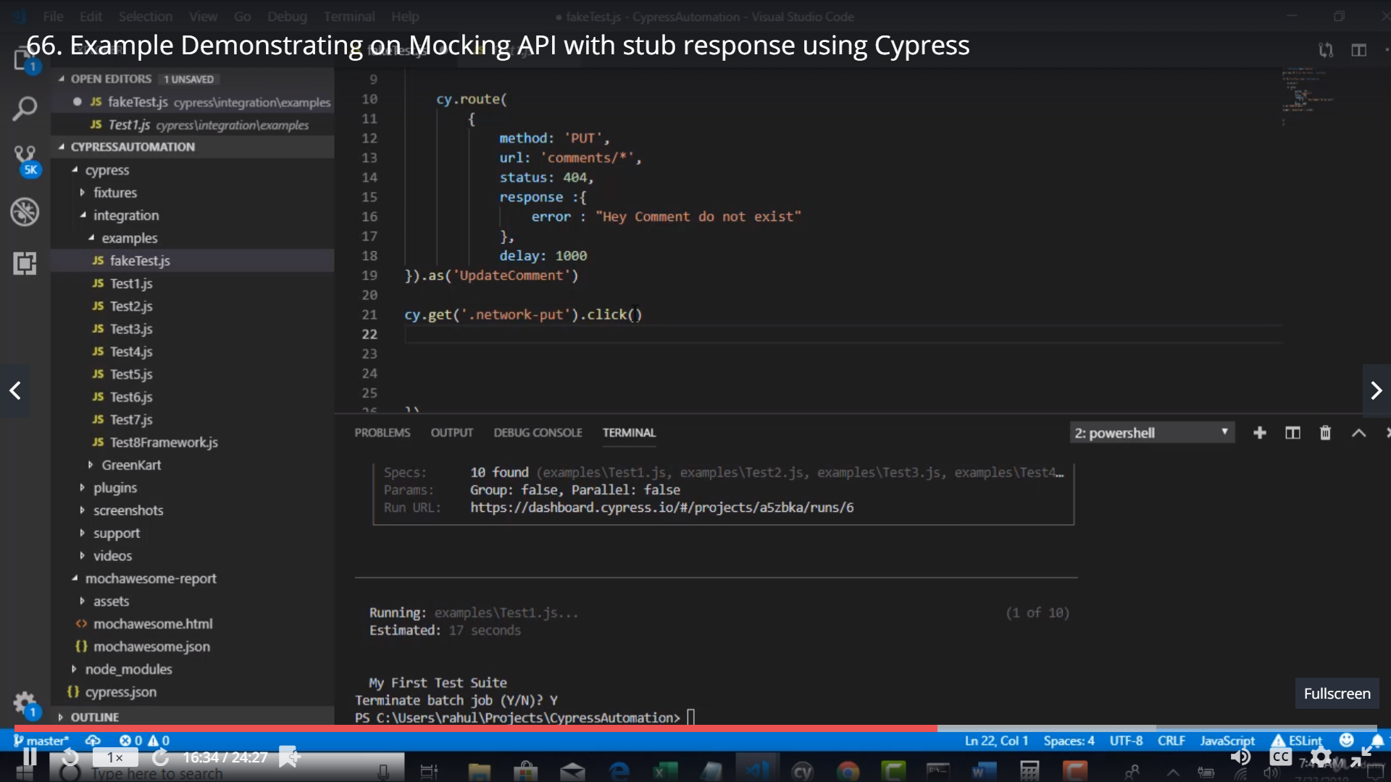

Once u get the fake response of the api .. u need to talk to the developers to ensure whr in the html dom would the message be binded..

So u can grab tht element and validate the response…

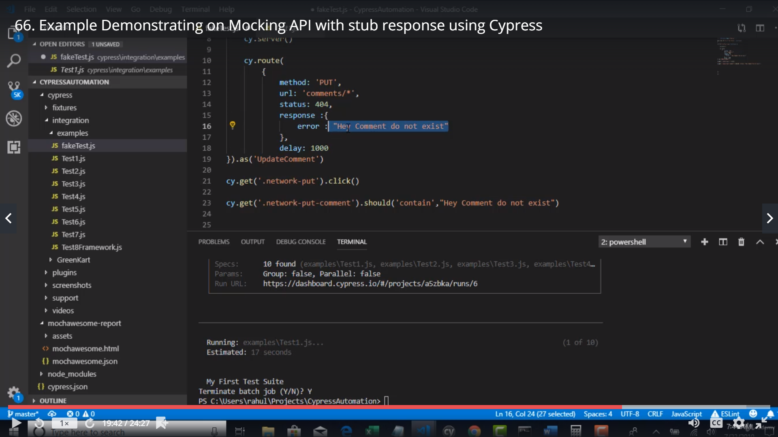

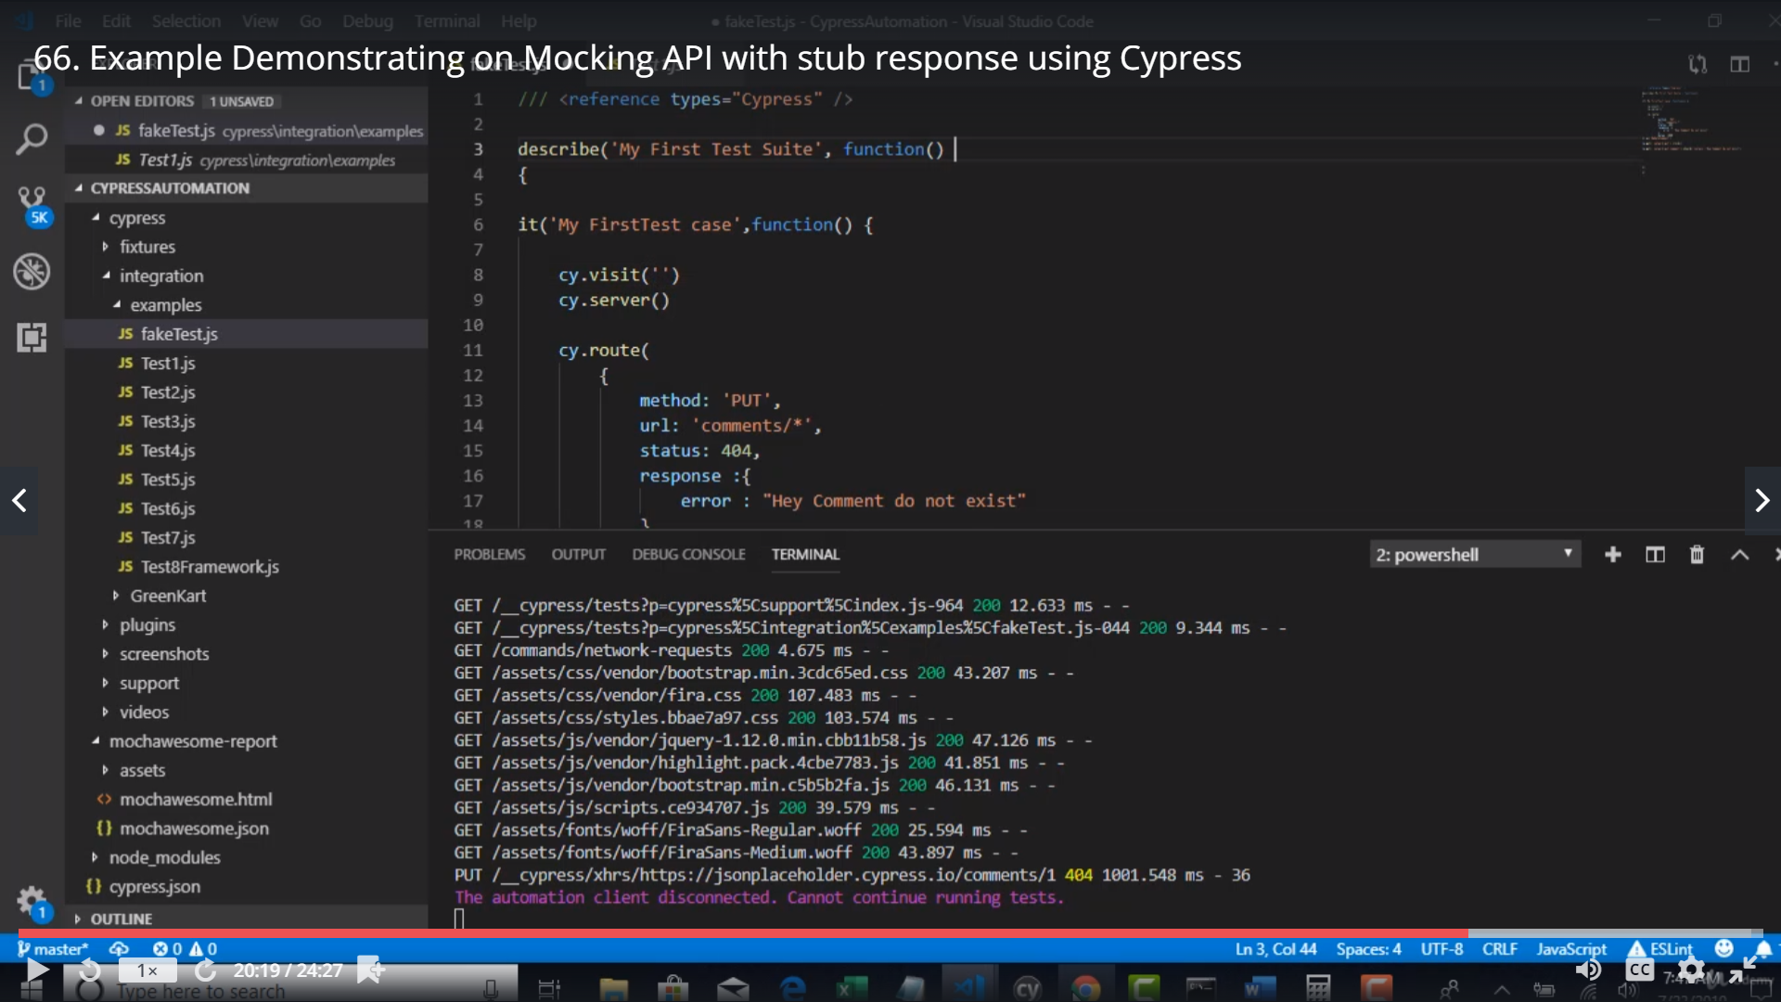

Run it

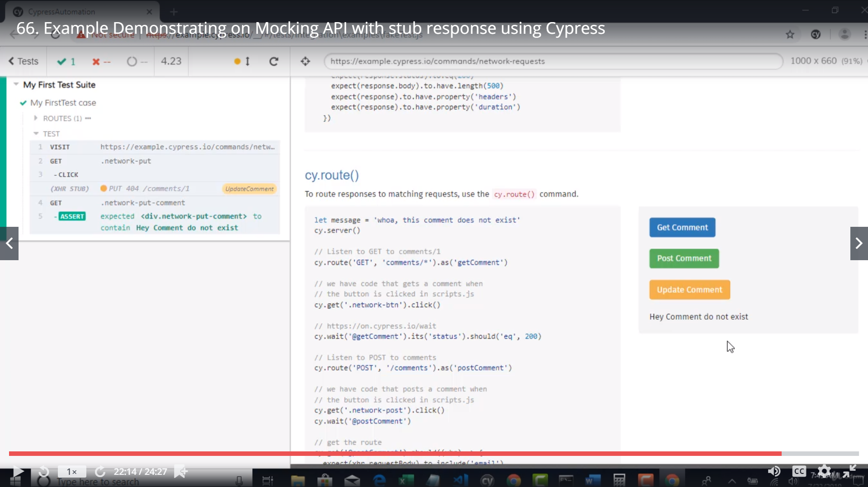

If wrong error message is provided – valdate tht

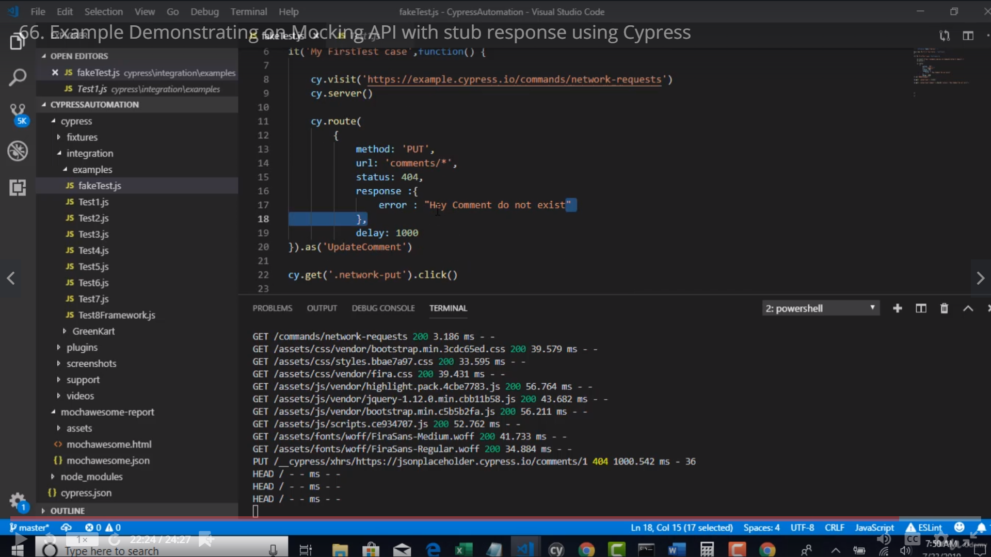

Run it

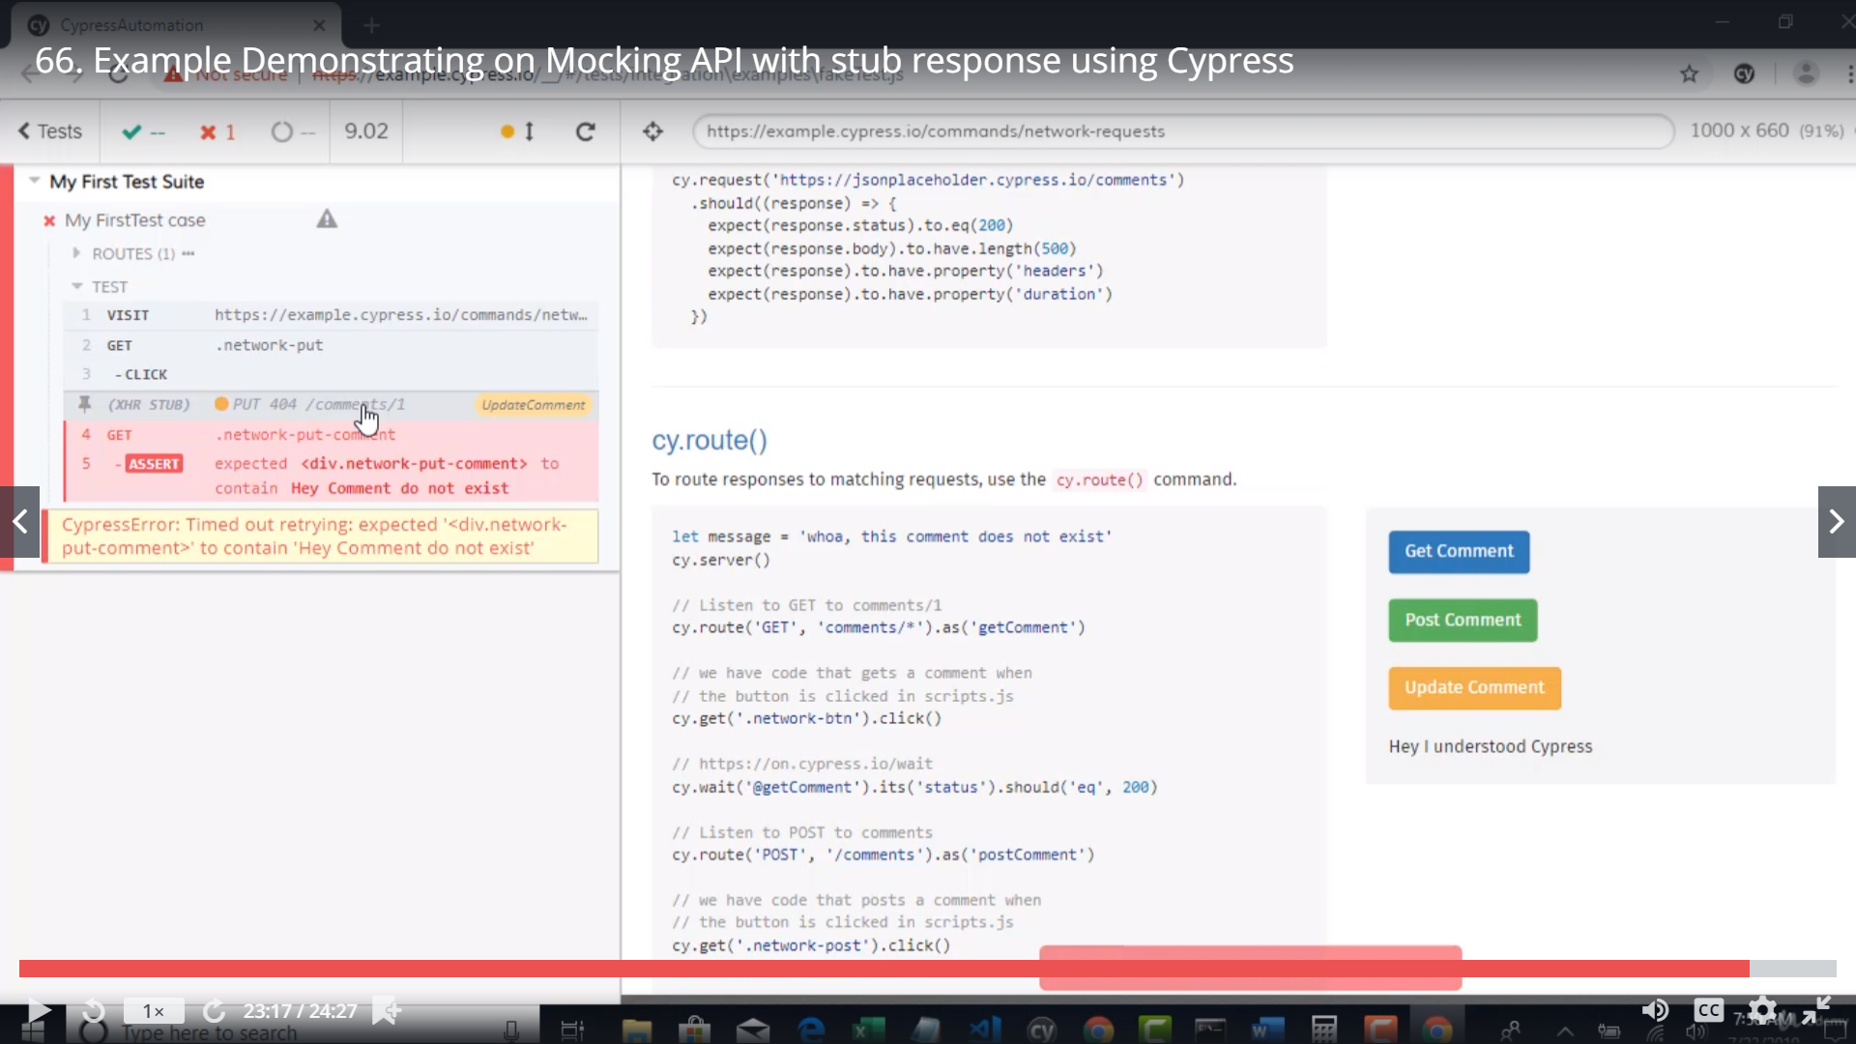 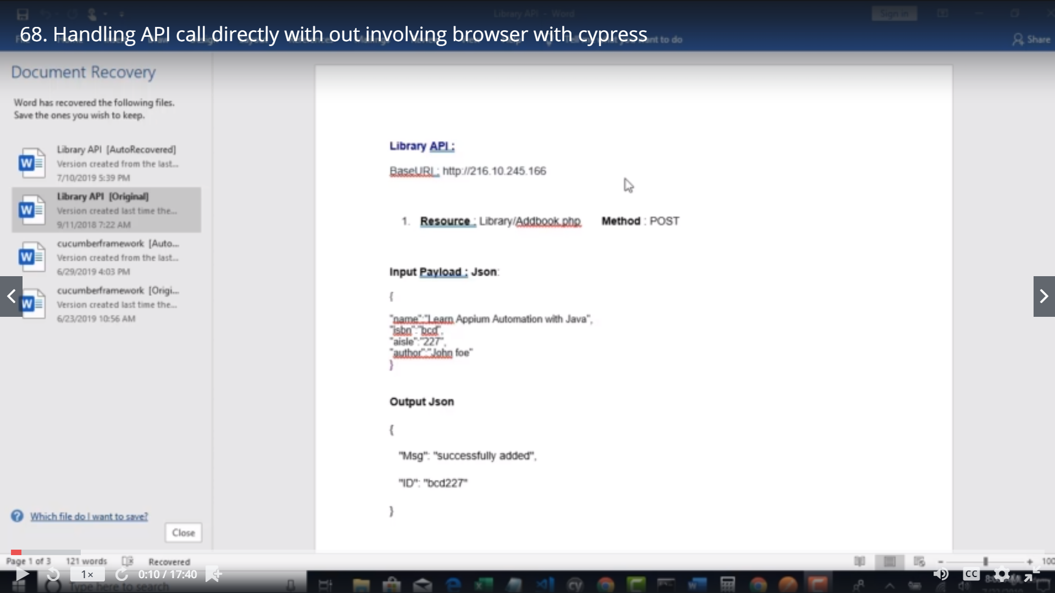 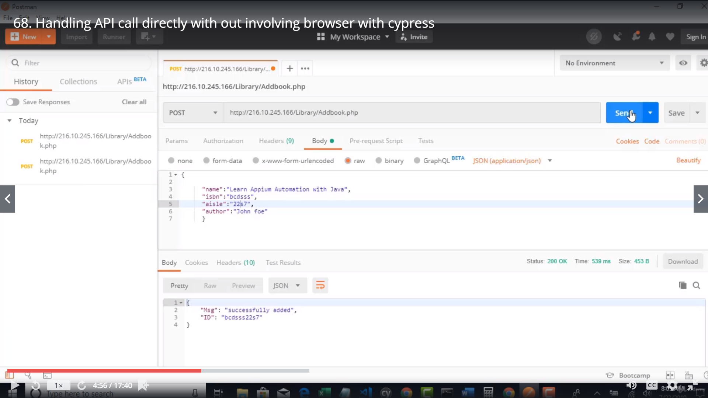 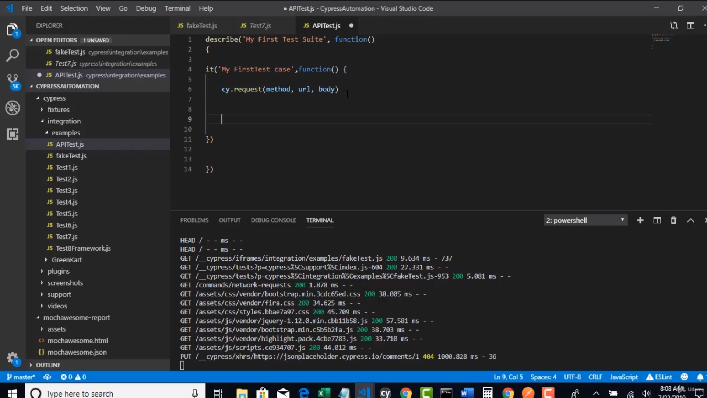 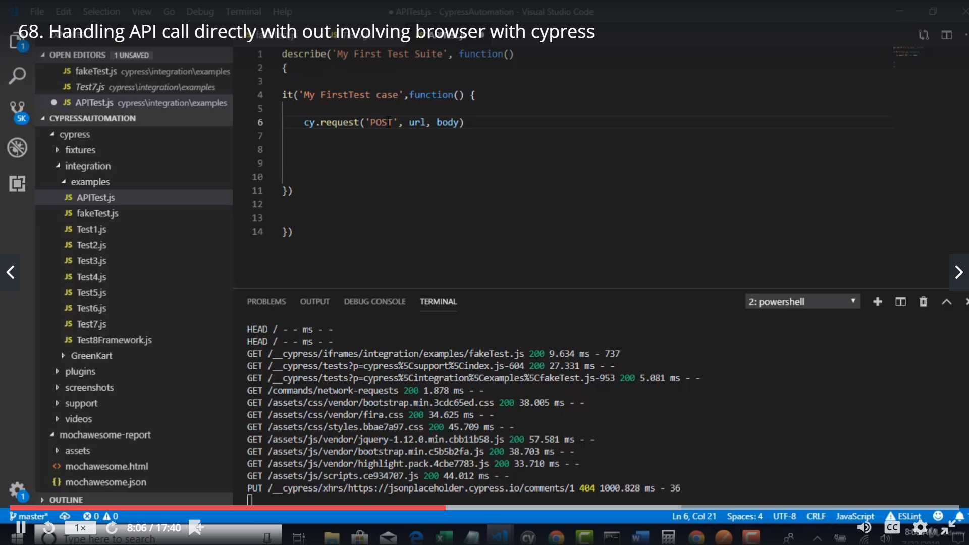 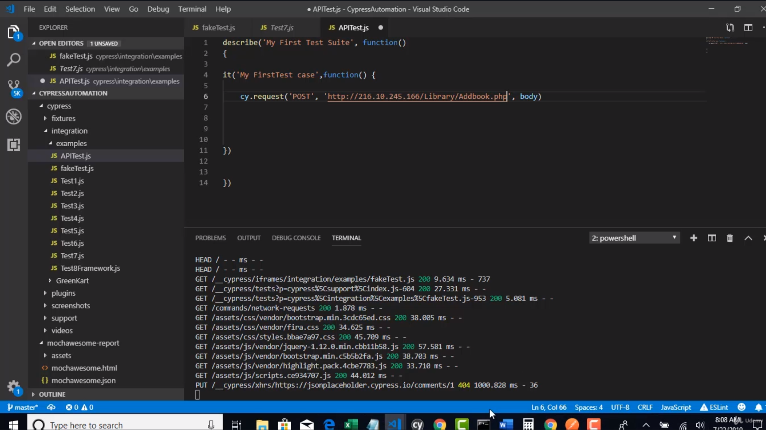

Copy the body from postman mouse over the body

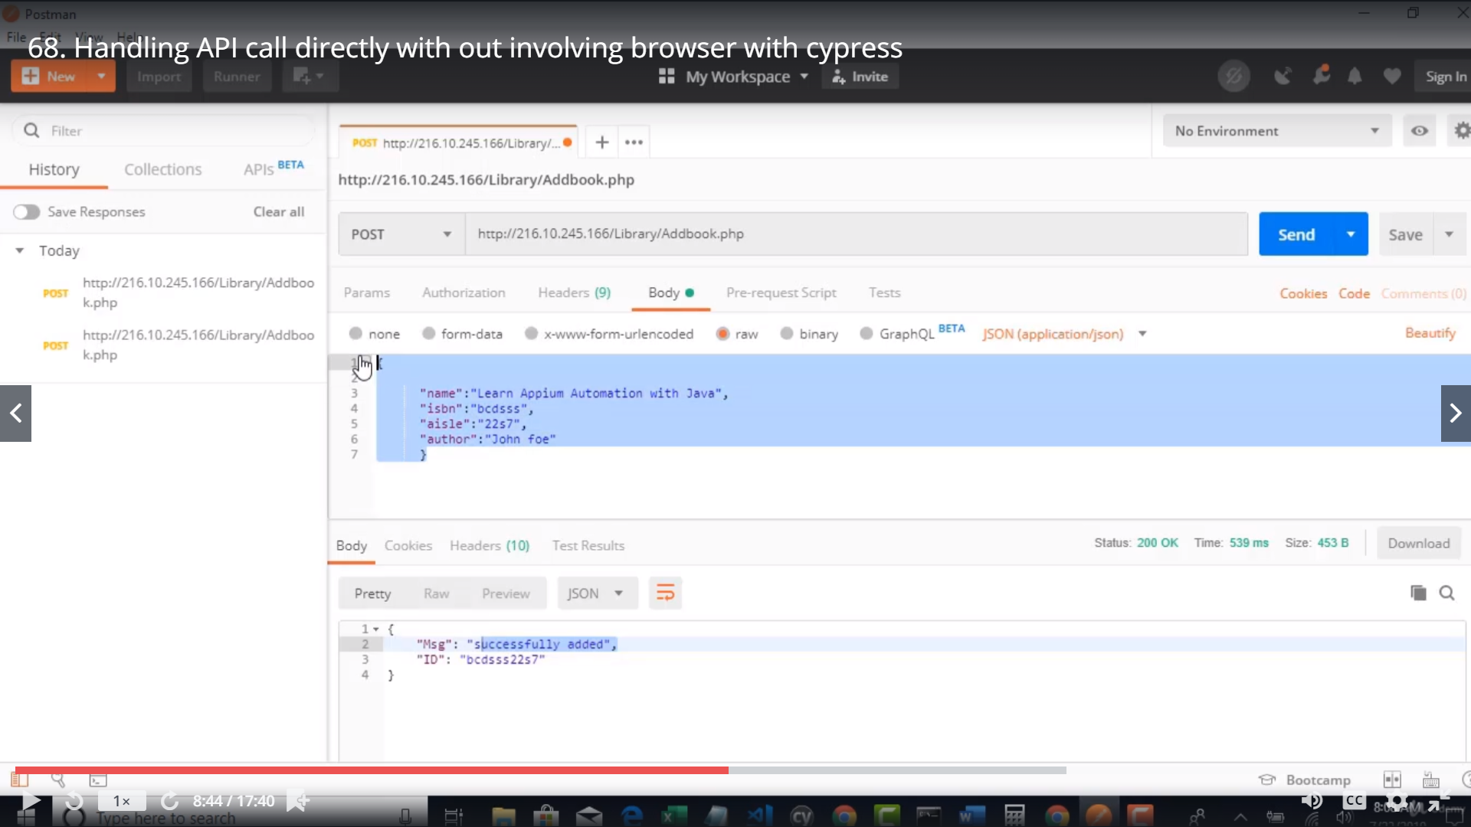 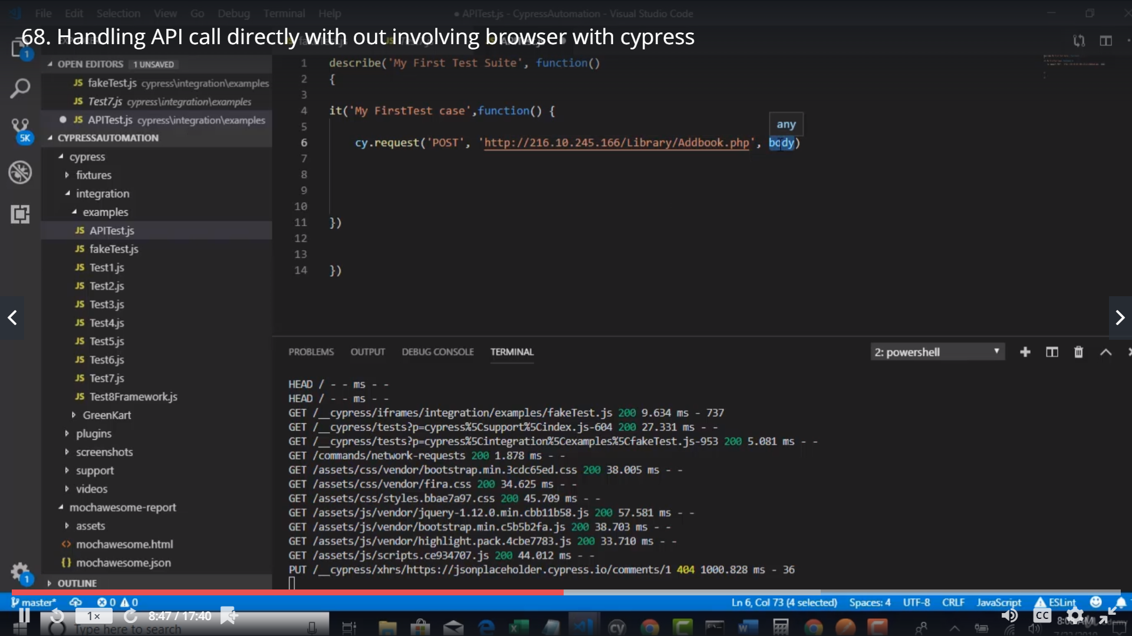 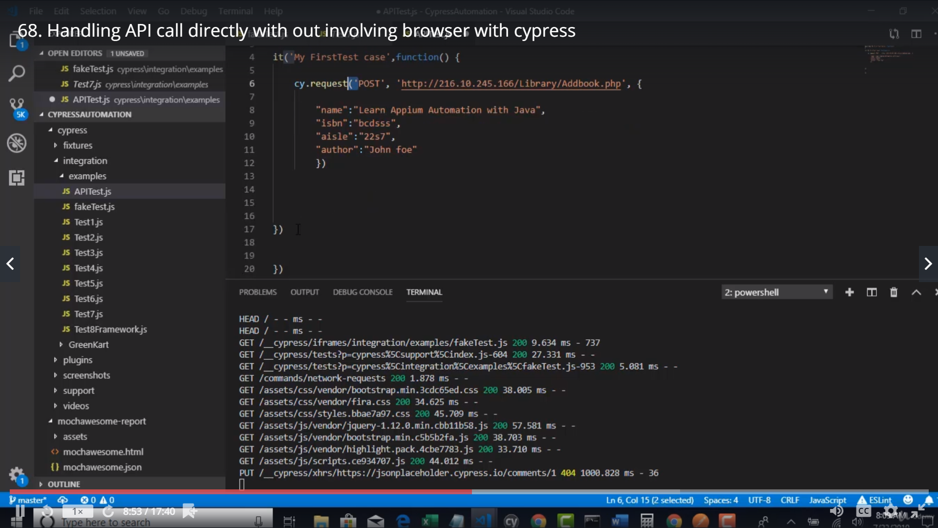

The try to write a promise and assert

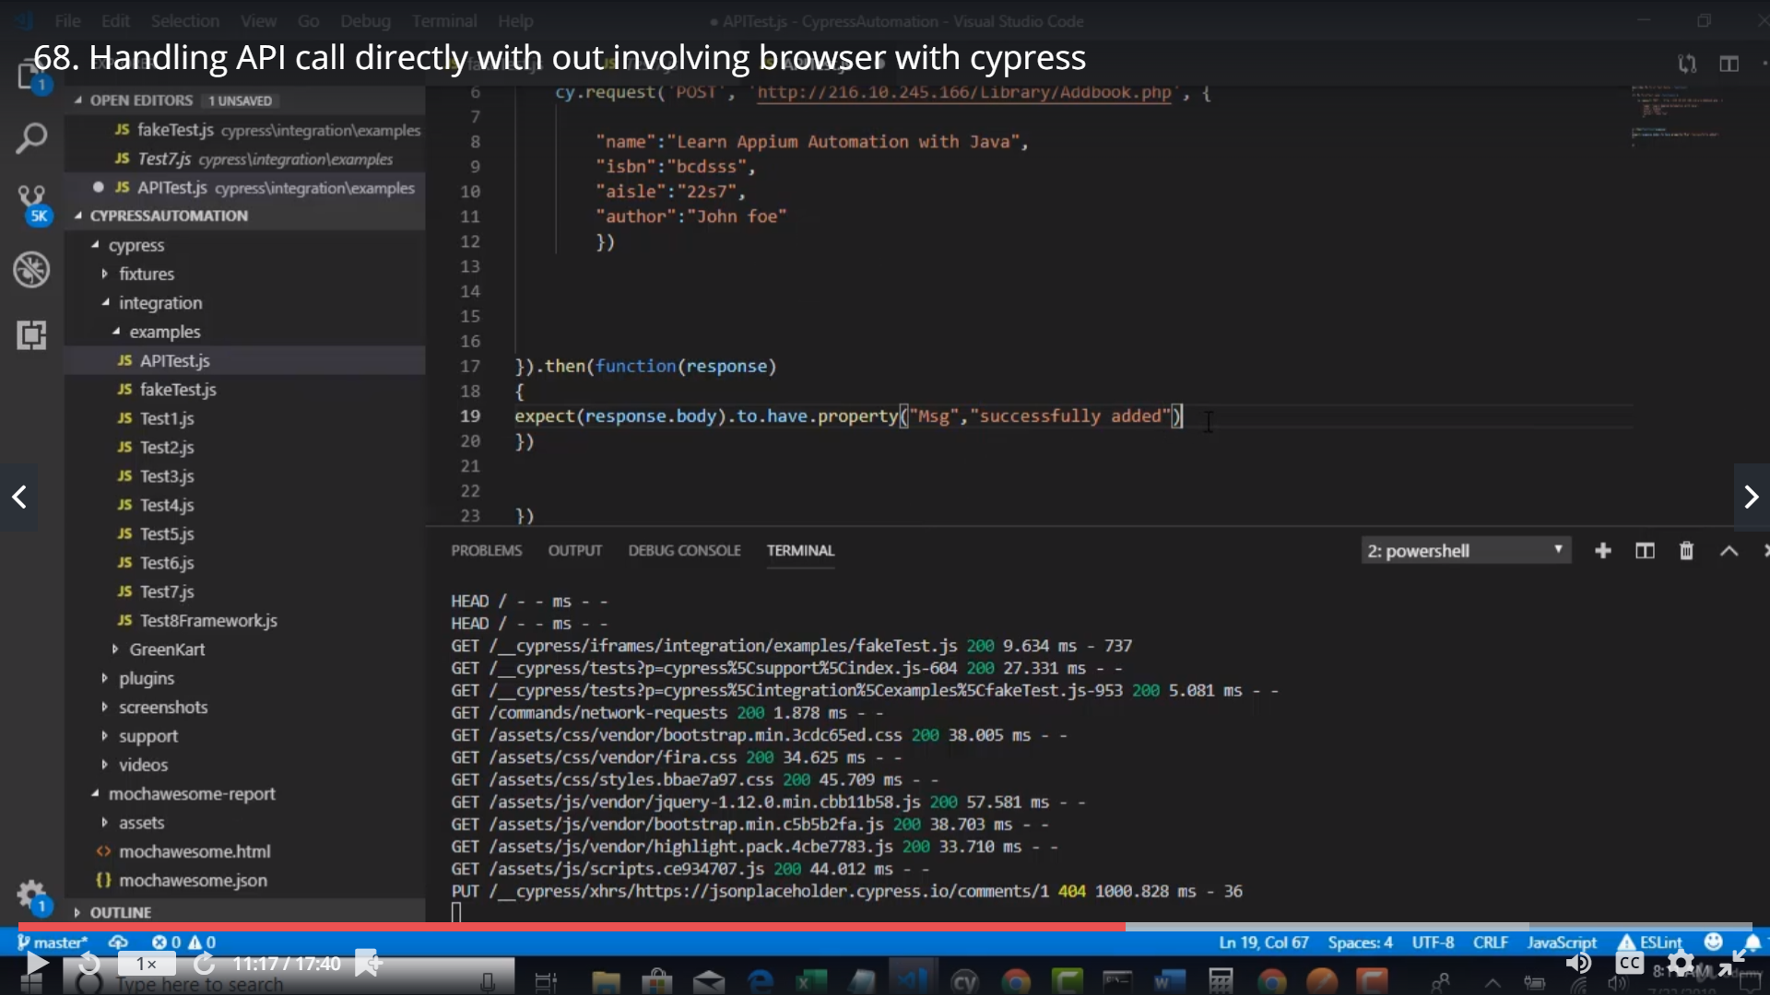

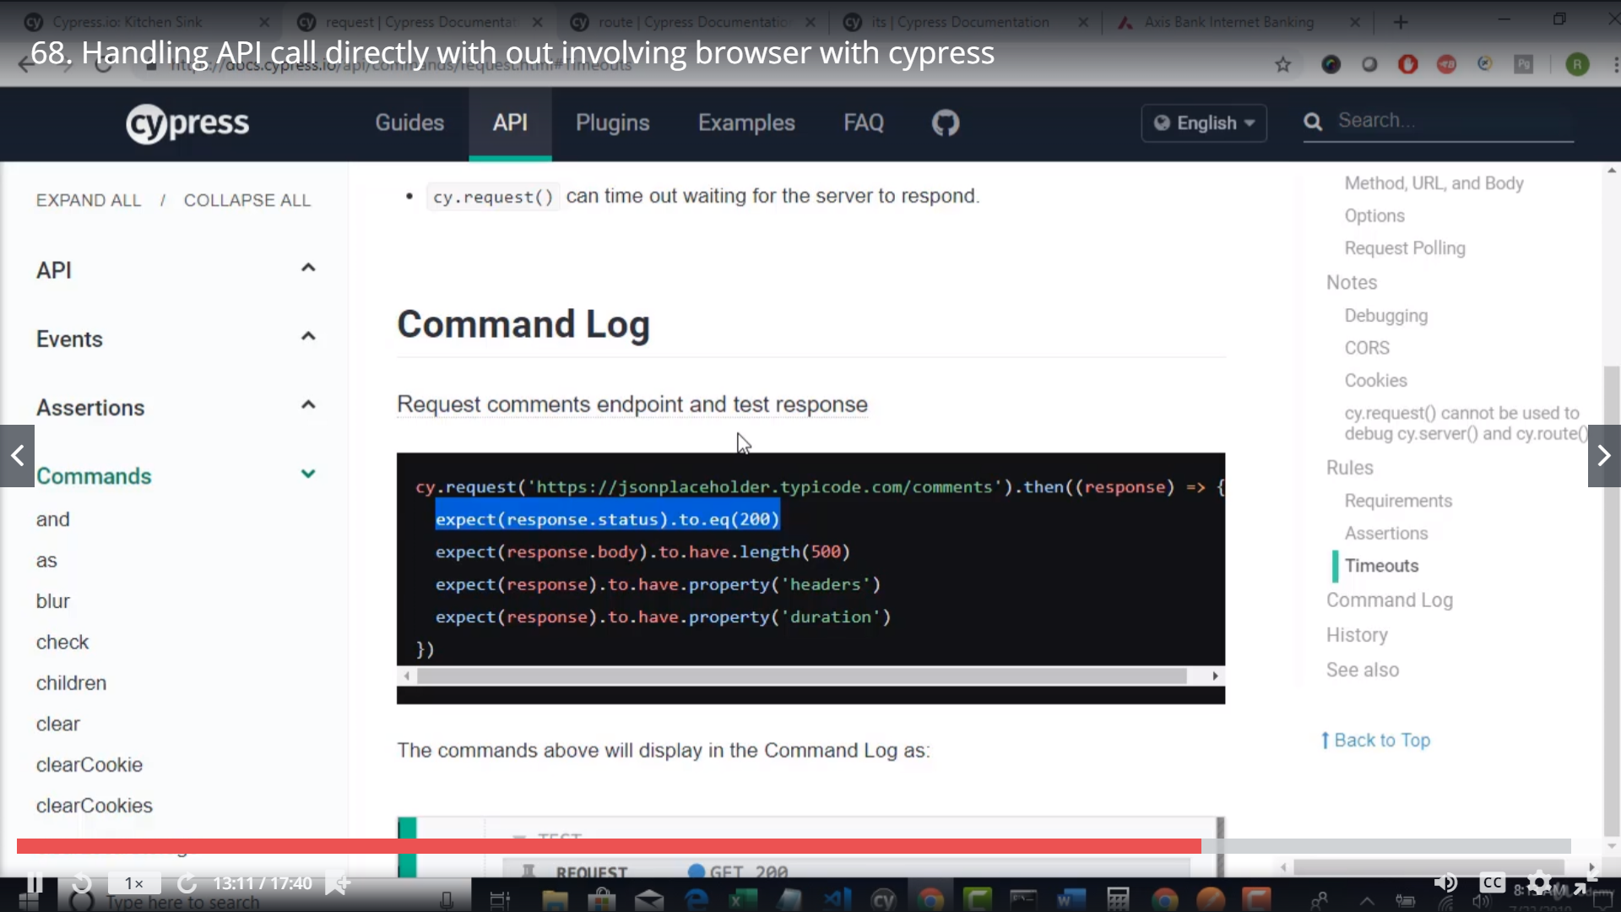 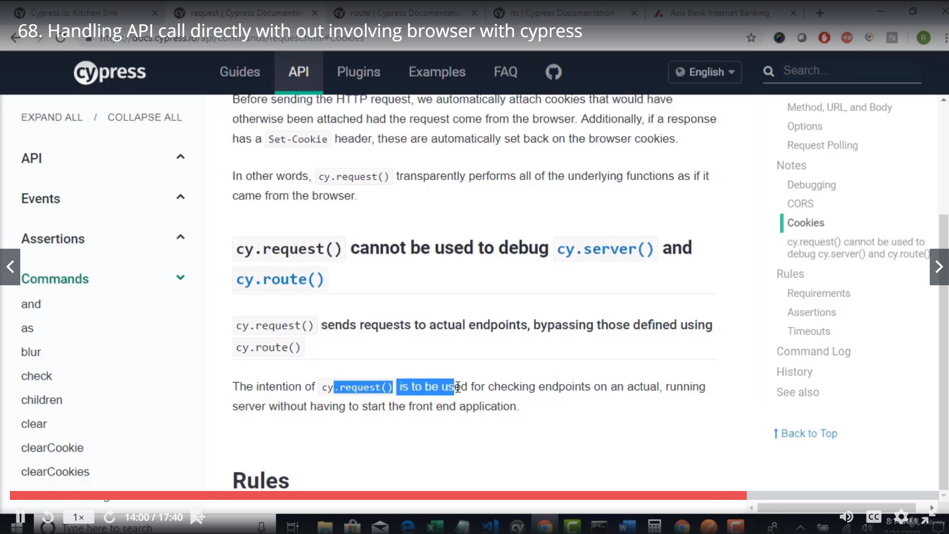

Run the above .. it will fail… change the code as below..

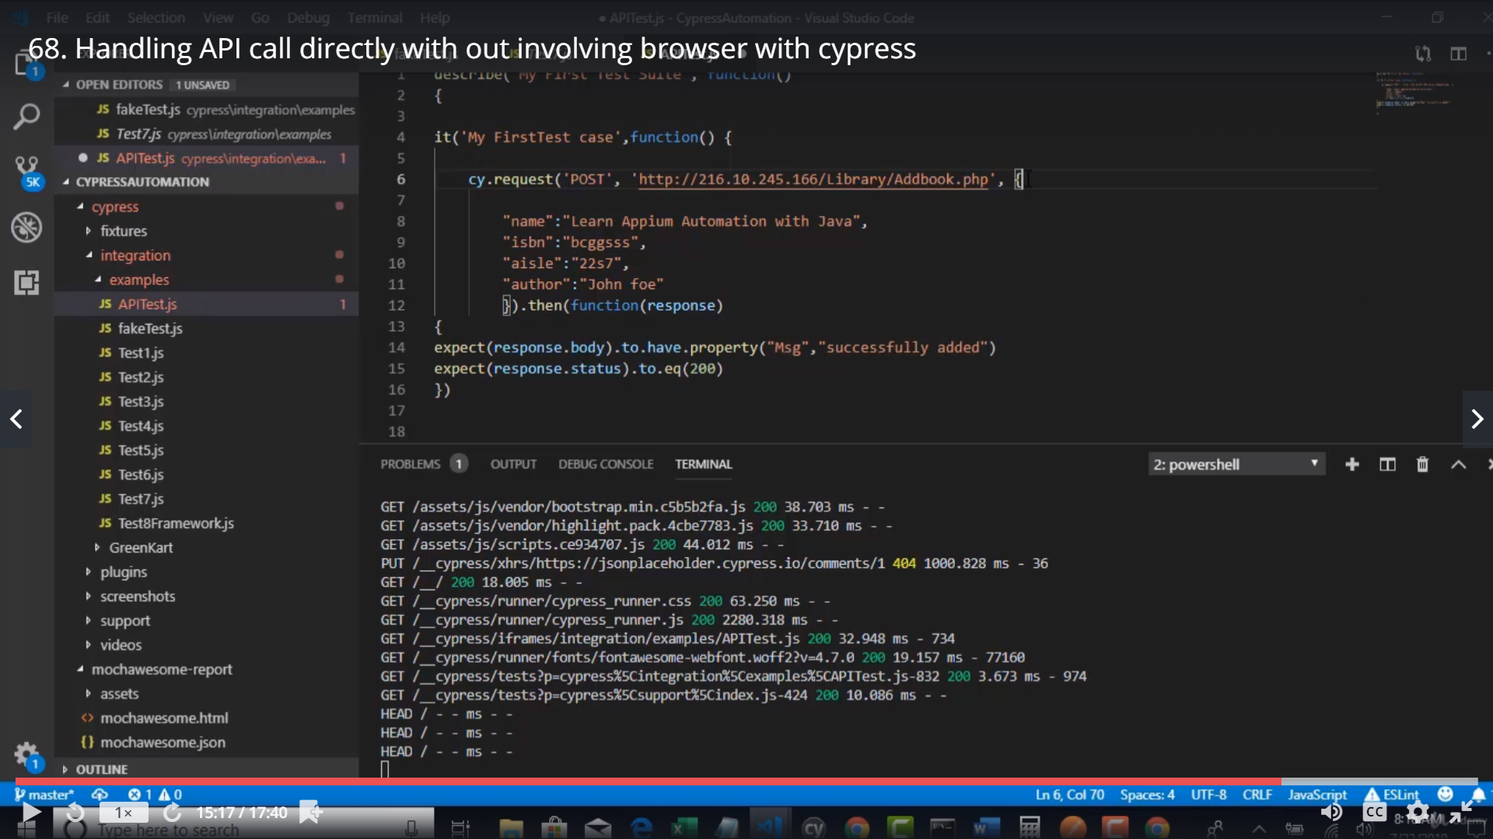 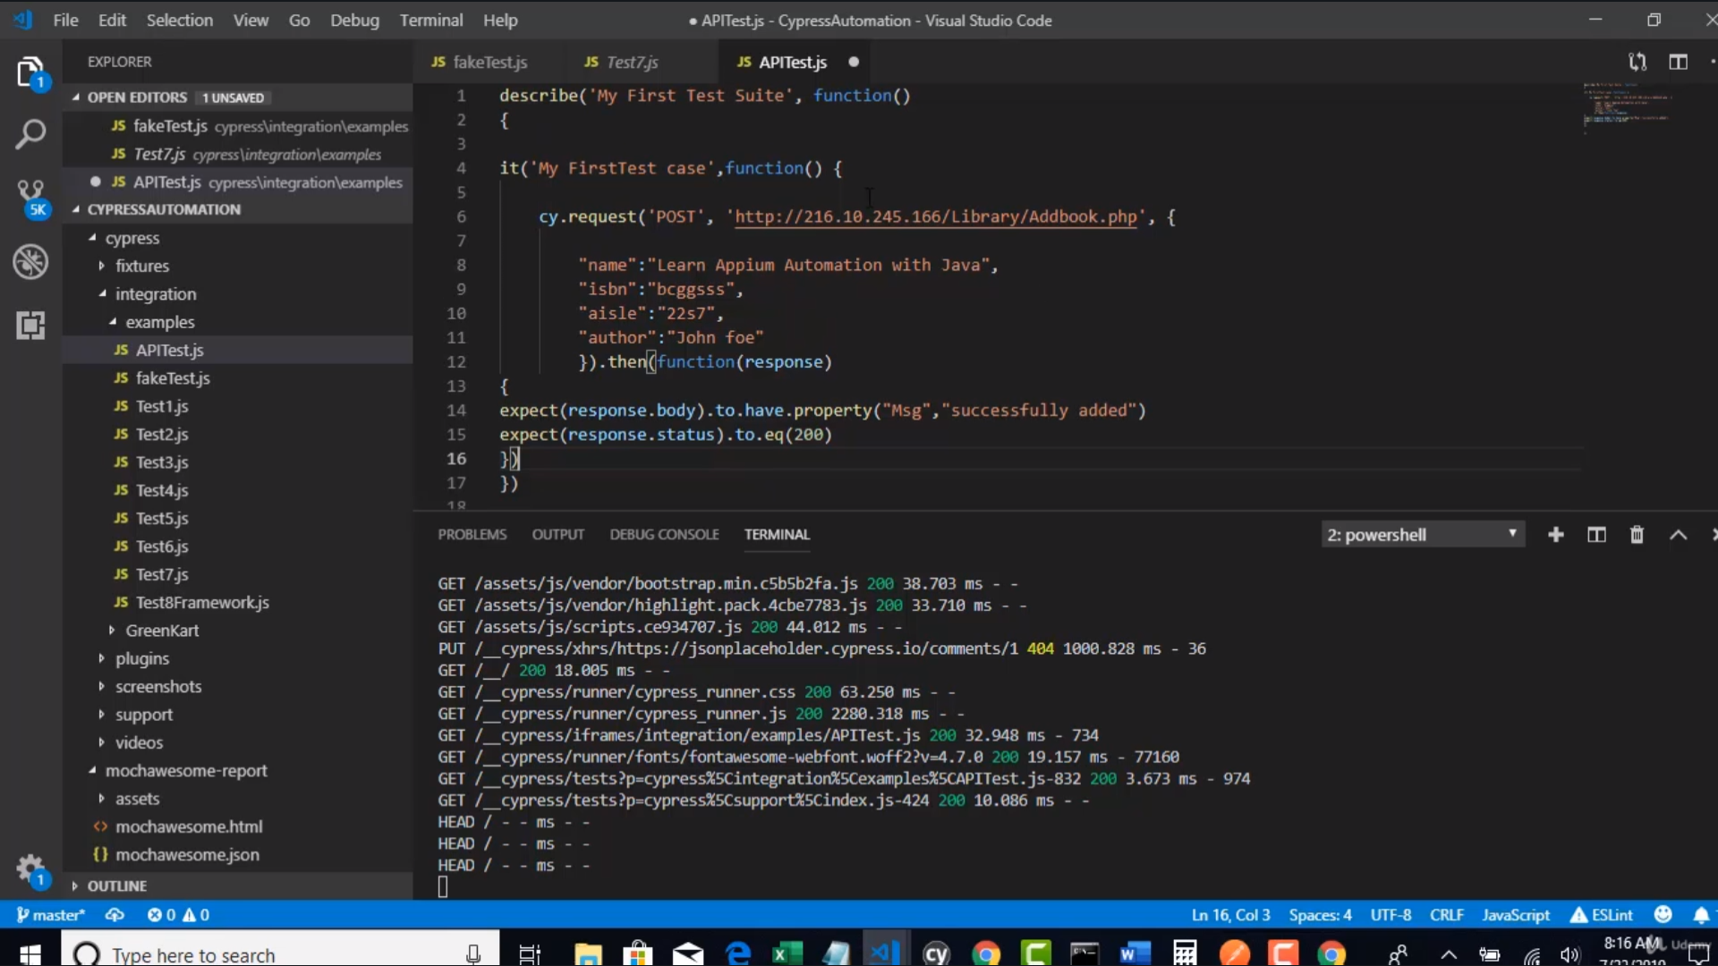 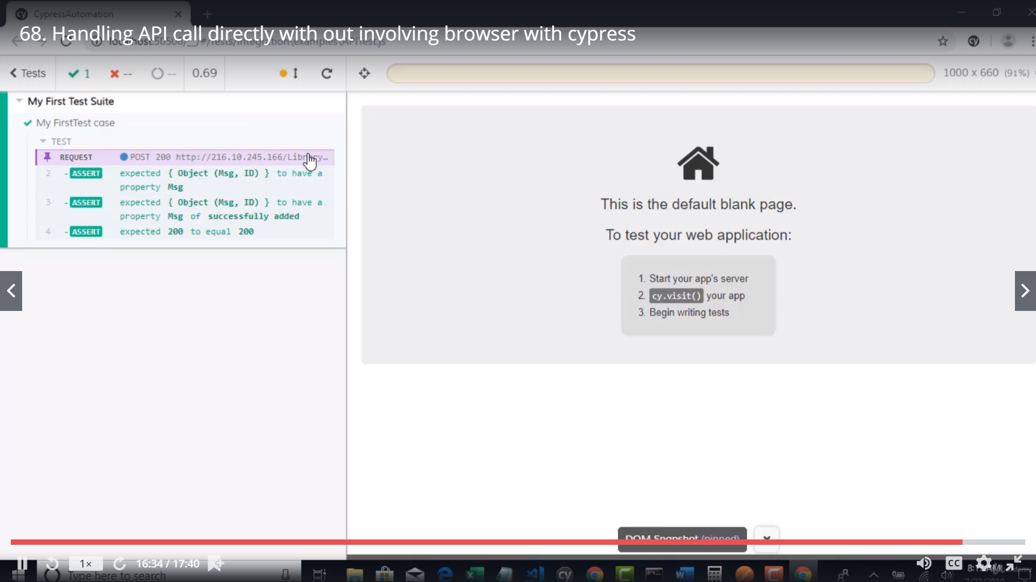

If project is rest only use rest assured… instaed of cypress..